Statics
Tests for lectures 1-4

1. Define the term rigid body.
A completely rigid body means a body, a formation in which the mutual distance between two arbitrary points does not change during the movement.
2. Define the term mass point.
A mass formation whose dimensions can be neglected. In statics we understand the point of the body, where we imagine the concentrated mass of the entire body.
3. Define the term Power Pair.
Two forces parallel to each other, the same size, in opposite directions, not lying on a support. The force couple has no sliding action, but only a rotational action corresponding to the product of one of the forces and the vertical distance between the forces. The effect of a power pair is given by its moment.
4. Explain the axiom of inertia (Newton's law)
A body that is in relative rest or uniform straight line motion will remain in that state until it is loaded by an external force or system of balance.
5. Explain the axiom of action and reaction (Newton's Law).
Each action is accompanied by an equal, counter-reaction. This indicates that the effect of one body on another has the same size of flax in the opposite direction as the effect of the other body on the other.
6. Explain the axiom of maintaining the effect
The effect of a given force system does not change when we add or remove a balance-of-force system.
7. Explain the axiom of vector powers
The result R ̅ of two different parallel forces (F_1) ̅ and (F_2) ̅ is equal to their vector sum R ̅ = (F_1) ̅ + (F_2) ̅ and passes through the intersection of their charge carriers.
8. How many degrees of freedom do kinematic pairs of the first grade usually take?
a) 1
(b) 2
(c) 3
9. How many degrees of freedom do kinematic second-class couples typically take?
a) 1
b) 2
c) 3

10. How many degrees of freedom does a mass point have in the plane?
a) 1
b) 2
c) 3
Tasks for lecutres 5-8
Task 1: The G-weight roller stands on a horizontal surface and is held by an inclined wall under the force F. Determine the cylinder pressure on both surfaces if the cylinder weight G = 800 N, the force F = 1000 N and the angle α = 50 °.
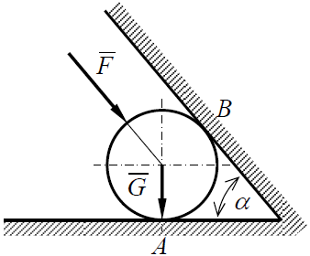
N_{A} = 2105,41 N, N_{B} = 839,10 N

Task 2: The load on the weight G is at the point A, which is hung on the spatial beam console. These are a, the height b and the width 2c. Determine the axial forces in elements 1, 2 and 3. Analyze the problem G = 1200 N, a = 1500 mm, b = 875 mm, c = 450 mm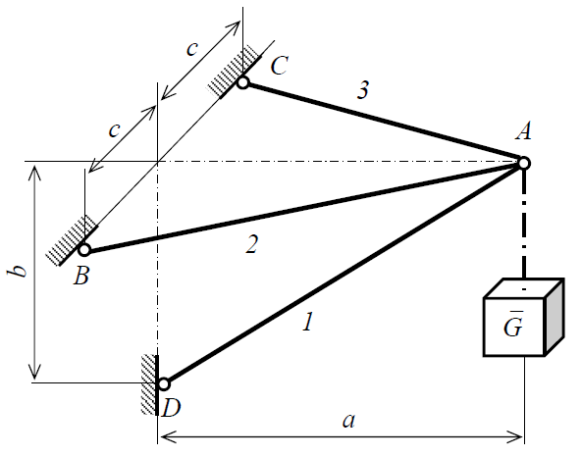
: N₁ = 2382 N, N₂ = 1074 N, N₃ = 1074 N

Task 3: The angular support ABC carried by joint A and sliding bed B is loaded with a continuous load of intensity q = 50 Nm-1 and a single force F = 200 N. Determine the reactions in joint A and sliding bed B, if a = 1 m. Solve the problem analytically
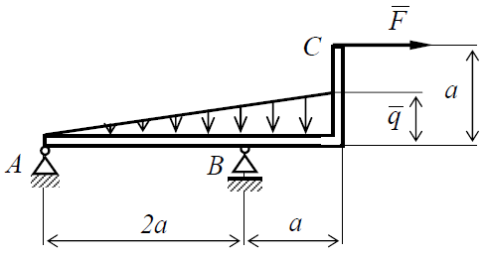
A = 224 N, B = 175 N

Tasks for lectures 9-12
Exercise 1: The system of two bodies in one plane is loaded by uniform continuous load with the intensity q = 50 Nm-1. Which reactions result from the boundary conditions for a = 2 m? Solve the problem analytically
.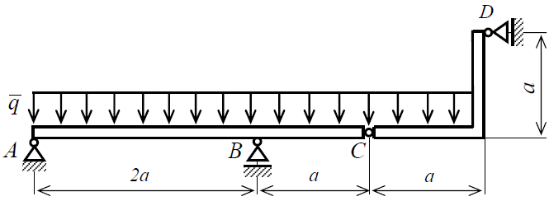
A = 56N, V = 375 N, C = 112 N, D = 50 N

Task 2: The surface jet system is fixed and loaded as shown.
1.) Evaluate the task overall in terms of form and static safety, both inside and out
2.) Determine the extent of reactions in external bonds analytically.
3.) Determine the size of the axial forces in internal boundary conditions, elements, analytically using the method of contact points.
4.) Calculate and test the axial forces in three appropriately selected bars according to the cutting method.
Given: a = 0.5 m, α = 20 °, F1 = 2 kN, F2 = 3 kN
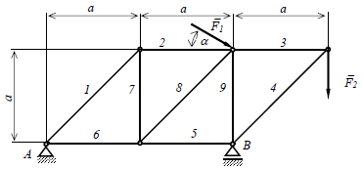
A = 3,08 kN, B = 6,12 kN, N₁ = 3,45 kN, N₂ = 2,44 kN, N₃ = 3 kN, N₄ = -4,24 kN, N₅ = -3 kN, N₆ = -0,56 kN, N₇ = -2,44 kN, N₈ = 3,45 kN, N₉ = -3,12 kN

