3rd BIP on International training in ‘Business Case Analysis’
02 December – 06 December, 2024
Antwerp


Take on the experience
in a multidisciplinary & intercultural team
and learn to analyse case studies based on
methodological and theoretical principles.

Working Space:
Thomas More ‘Campus National’, Kronenburgstraat 62, 2000 Antwerp
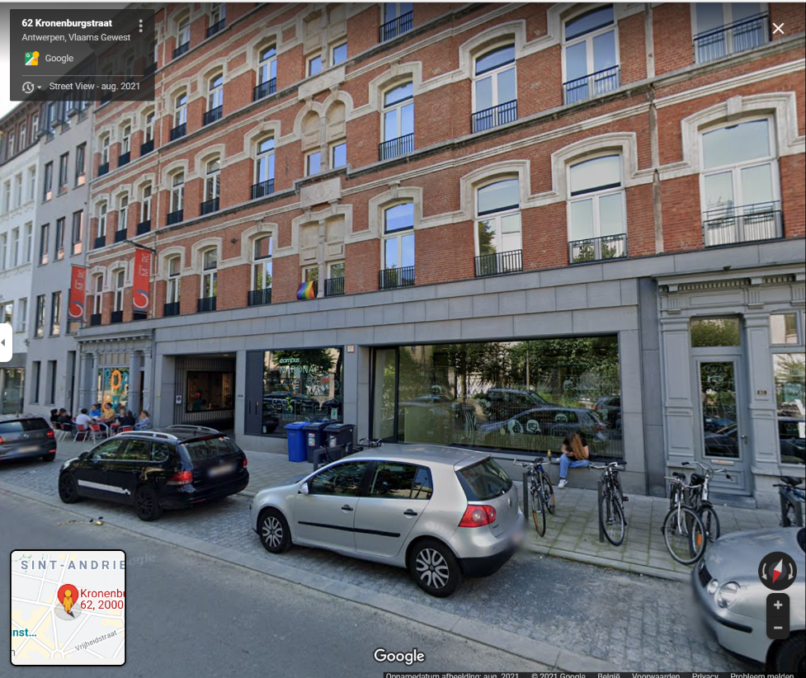
Airports nearby Antwerp:
Brussels Airport (50 km from Antwerp): all airlines Brussels National Airport
The railway station at the airport is on Level -1.
Book your trainticket via Belgiantrain from Bussels Airport to Antwerpen-Centraal
Brussels South (120 km from Antwerp): only Low cost airlines Brussels South (Charleroi)
You should take the bus from the airport to the railway station of Charleroi Sud.
Book your trainticket via Belgiantrain from Charleroi-Sud to Antwerpen-Centraal
NL-Eindhoven Airport ( 90 km from Antwerp): only Low cost airlines Eindhoven Airport (The Netherlands)
You should take the bus from the airport to the railway station of Eindhoven.
Book your trainticket via B-europe.com from Eindhoven to Antwerpen-Centraal
You also can look at the website of Flibco to see if you find bus connections to Antwerpen.

COVID-rules, Belgium:
As for the moment there are no rules anymore. However, we can not know what will happen in the coming months.

The Program-Preliminary
As this is a Blended Intensive Programme, we need to come together physically for at least 5 days. Next to this, we will work together online for two moments.
First online meeting with all participating students; To be decided by the participating partners ….
In the physical part of this BIP, students will combine theoretical and practical knowledge to solve case studies. They will apply the learned business knowledge and the methodological skills related to case studies into business problems. In the end they will deliver a coherent presenation successfully.
Day | Hours | Subject
1 Dec.  Sunday |  | Arrival to Belgium for international students.
2 Dec.  Monday | 09:30-10:30  10:45-12:30  12:30-13:30  13:30-19:00  19:00- … | Welcome and Ice-Breaking  Case Studies and case competitions  Lunch  Organised activity: Discover Antwerp + dinner  Free time
3 Dec.  Tuesday | 09:30-11:00  11:15-12:30  12:30-13:30  13:30-15:00  15:15-16:30  17:00- … | Case solving mindset and process  Case reading and understanding  Lunch  Case analysis  Strategy Development  Free time
4 Dec.  Wednesday | 09:30-11:00  11:15-12:30  12:30-13:30  13:30-19:00 | Creating and structuring the presentation  Presentation delivery  Lunchtime  Organised activity + dinner ‘Pizza’
5 Dec.  Thursday | 9:30-12:30  12:30-13:30  13:30-16:30  17:00-… | Case Study handout, reading and analysis  Lunchtime  Preparing the presentation and pitch  Free time
6 Dec.  Friday | 9:30-12:30  12:30-13:00 | Final presentations and individual evaluation/feedback to each team.  Closing of the week and departure  Remark: Everybody should be able to stay untill 13:00 in Antwerp, Campus National.

Language: English
Benefits:
Certificate of attendance & 3 ECTS
+ social and cultural activities in a multicultural setting
No participation fee(*):
4 lunches and 2 eveningmeals included.
(*)students pay their travel and accommodation costs themselves
Accommodation
Mostly, students want to make their own reservations wherever they want.
Please, take into account the location of our workings space.
However, nearby, I can recommend the youth hostel Pulcinella,
Bogaardeplein 1, BE-2000 Antwerpen
antwerpen@vjh.be / Tel. +32 3 234 03 14
https://www.jeugdherbergen.be/en/antwerp
Recommended Hotel for Lecturers:
IBIS Hotel Antwerpen centrum, it has a good value for the price you pay.
Of course, you always can look at Booking.com or at Spending the night in Antwerp.
Regsitrations of the participating students should be done BEFORE Oct. 18th, 2024
Please let your students register via: https://webforms.thomasmore.be/view.php?id=1361179
Partners who receive this invitation.
Please distribute this invitation internally if necessary.
Prof. Armbruster | Christian |  | Germany | Hochschule Kaiserslautern | Christian.armbruster@hs-kl.de
Prof. Dr. Innuse | Gunta |  | Latvia | BA School of Business and Finance (lecturer) | gunta.innuse@ba.lv
Prof. Dr. Chalupova | Martina |  | Czech Republic | College of Polytechnics Jihlava (lecturer) | Martina.Chalupova@vspj.cz
Troupová | Alžbeta |  | Czech Republic | Institute of Technology and Business (lecturer) | troupova@mail.vstecb.cz
Pool | Jaap |  | Netherlands | HAN University | Jaap.pool@han.nl
Fusteforne | Francesc |  | Spain | Universitat de Girona | francesc.fusteforne@udg.edu
Szász | Levente |  | Romania | Babes-Bolyai University | levente.szasz@econ.ubbcluj.ro
Kovács | András |  | Hungary | Budapest Business School | kovacs.andras2@uni-bge.hu

