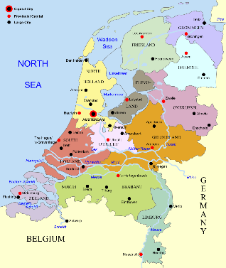
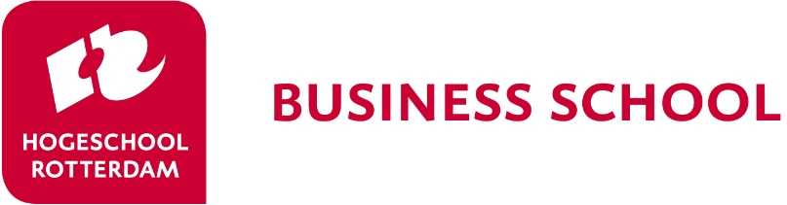
…
…
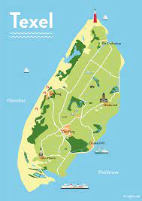

We’re all going on a trip!
The fall edition of the Rotterdam BIP is scheduled for 10 -14th October 2022. This time, not in the harbour city, but on the beautiful Isle of Texel, in the city Den Burg. We’ll move the entire event tot his beautiful island. You will experience the island with its dunes and beaches and will work on an international business case, provided by a local international company.
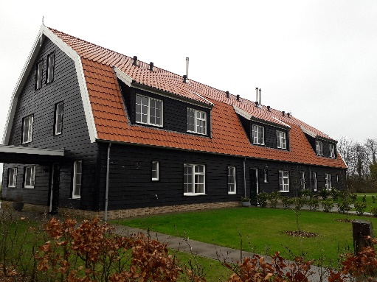
In this brochure we give you the first key characteristics of this week.
Where will we stay
We will all stay in a beautiful sustainable group accommodation “Nieuw Leven”. You’ll stay in a double room, with en suite.
How to get there
On Monday 10th October 2022 a bus will depart from Schiphol Airport. The bus takes you to Den Helder, where you will take the ferry. The last stretch will be done the Dutch way: by (electrical) bike.
BIP (blended intensive program) This program is a BIP. This means that a few online events are scheduled. Participation is mandatory.
There will be 2 meetings prior to the week and one meeting after the week on Texel.
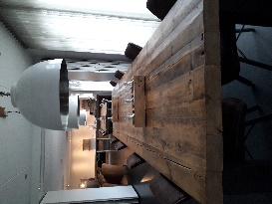
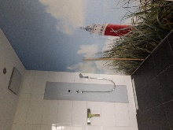

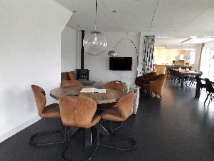
The business Case: De Wit Specialty Oils How a small island can have so much impact on the world wide industry of oils. De Wit specialty oils will provide you with a challenging business case. Sneak peak: www.dewitoils.nl
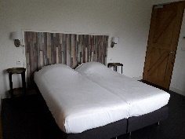

What do you get?
The price for this week is € 250
What you get is transportation to Texel from Schiphol airport (and back). 4 nights in the luxurious accommodation of Nieuw Leven, 4 breakfasts, 4 lunches, 1 superb barbecue, experiencing the island by bike, work on an international case, meet great people…...
How to subscribe
Deadline: 8th July 2022
Subscription: form at university

Preliminary program:

Monday 10th October:
Arrival at Schiphol
Transport to Den Helder by bus
Ferry to the Island
Bike tour to accommodation
Get to know each other
- Country presentation
- Sharing food
Visit De Wit Speciality Oils

Tuesday 11th October
Working on the case

Wednesday 12th October
Morning: working on the case
Afternoon: cultural activity

Thursday 13th October
Morning: Presentations
Afternoon: cultural activity
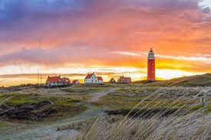
Barbecue

Friday 14th October
lean up and departure
Ferry to mainland
Bus to Amsterdam

