2nd BIP on ‘International training in Business Case Analysis’
04 December – 08 December, 2023
Antwerp

Take on the experience
in a multidisciplinary & intercultural team
and learn to analyse case studies based on
methodological and theoretical principles.

Working Space:
Thomas More ‘Campus National’, Kronenburgstraat 62, 2000 Antwerp
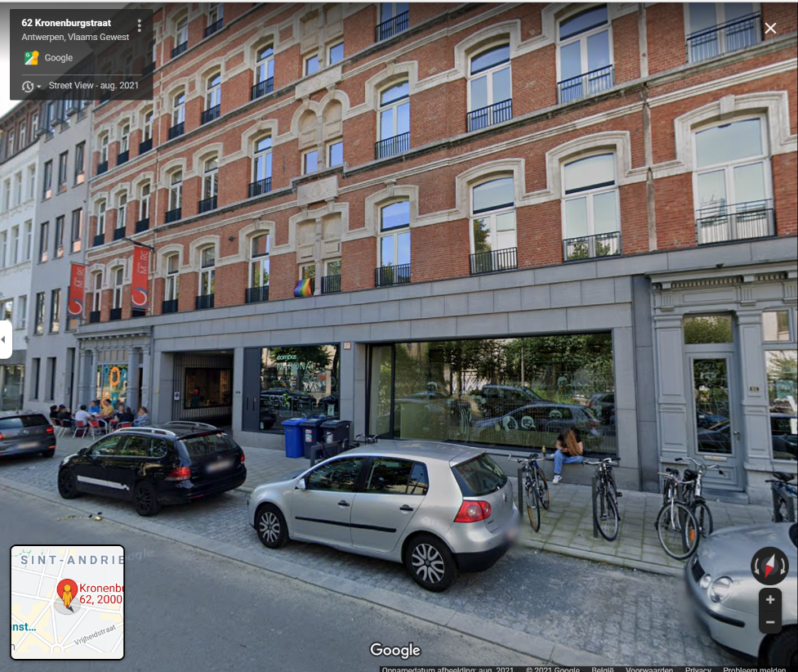
Airports nearby Antwerp:
Brussels Airport (50 km from Antwerp): all airlines Brussels National Airport
The railway station at the airport is on Level -1.
Book your trainticket via Belgiantrain from Bussels Airport to Antwerpen-Centraal
Brussels South (120 km from Antwerp): only Low cost airlines Brussels South (Charleroi)
You should take the bus from the airport to the railway station of Charleroi Sud.
Book your trainticket via Belgiantrain from Charleroi-Sud to Antwerpen-Centraal
NL-Eindhoven Airport ( 90 km from Antwerp): only Low cost airlines Eindhoven Airport (The Netherlands)
You should take the bus from the airport to the railway station of Eindhoven.
Book your trainticket via B-europe.com from Eindhoven to Antwerpen-Centraal
You also can look at the website of Flibco to see if you find bus connections to Antwerpen.

COVID-rules, Belgium:
As for the moment there are no rules anymore. However, we can not know what will happen in the coming months.

The Program-Preliminary
As this is a Blended Intensive Programme, we need to come together physically for at least 5 days. Next to this, we will work together online for two moments.
First online meeting with all participating students; To be decided by the participating partners ….
In the physical part of this BIP, students will combine theoretical and practical knowledge to solve case studies. They will apply the learned business knowledge and the methodological skills related to case studies into business problems. In the end they will deliver a coherent presenation successfully.
This shedule is just provisional and will change according to external visits still to be decided on.
Day | Hours | Subject
3 Dec.  Sunday |  | Arrival to Belgium for international students.
4 Dec.  Monday | 09:30-12:00  13:00-16:00  18:00- … | Ice-Breaking and a case analysis framework  Guidelines for an operational approach to case and problem analysis  Leisure time activity Antwerp
5 Dec.  Tuesday | 9:00-12:00  12:00-13:00  13:00-16:00  18:00- … | Pitfalls to avoid in case analysis  Lunchtime  Communicating case analysis  Leisure time activity Antwerp
6 Dec.  Wednesday | 9:00-12:00  12:00-13:00  13:00-16:00  17:30 | Work on Case Studies  Lunchtime  Leisure time activity Antwerp
7 Dec.  Thursday | 9:00-12:00  12:00-13:00  13:00-16:00 | Work on Case Studies  Lunchtime  Preparing presentation and pitch
8 Dec.  Friday | 9:00-12:00  12:00-13:00 | Final presentations  Closing of the week and departure  Remark: Everybody should be able to stay untill 13:00 in Antwerp, Campus National.

Remark: during the week we will organise also some visits and cultural activities.

Language: English
Benefits:
Certificate of attendance & 3 ECTS
+ social and cultural activities in a multicultural setting
No participation fee(*):
4 lunches and 2 eveningmeals included.
(*)students pay their travel and accommodation costs themselves
Accommodation
Mostly, students want to make their own reservations wherever they want.
Please, take into account the location of our workings space.
However, nearby, I can recommend the youth hostel Pulcinella,
Bogaardeplein 1, BE-2000 Antwerpen
antwerpen@vjh.be / Tel. +32 3 234 03 14
https://www.jeugdherbergen.be/en/antwerp

