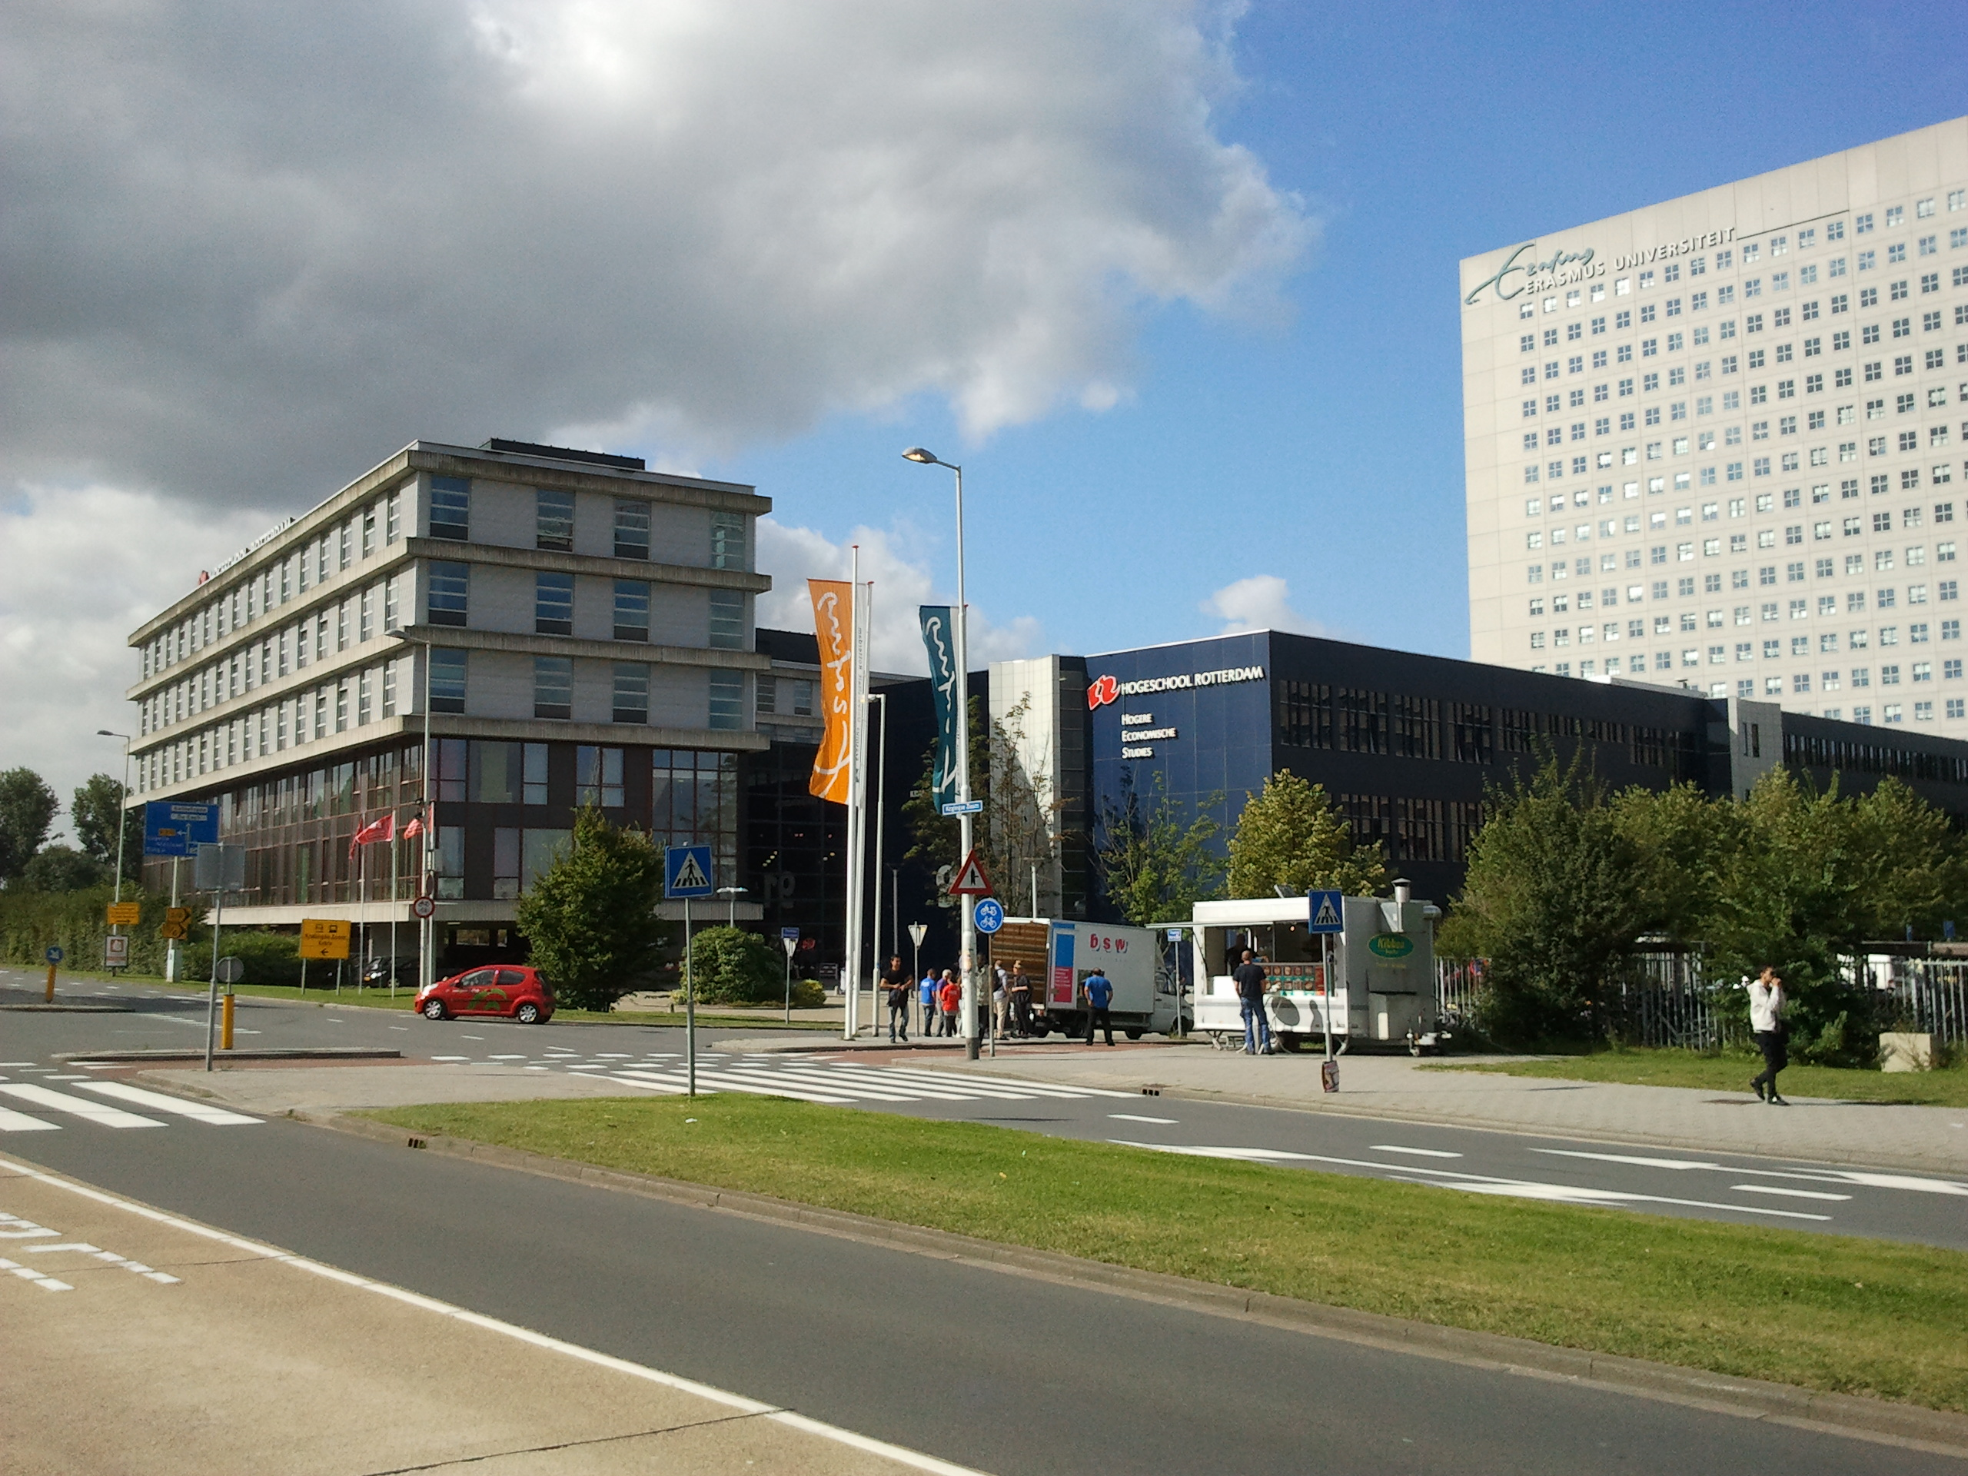

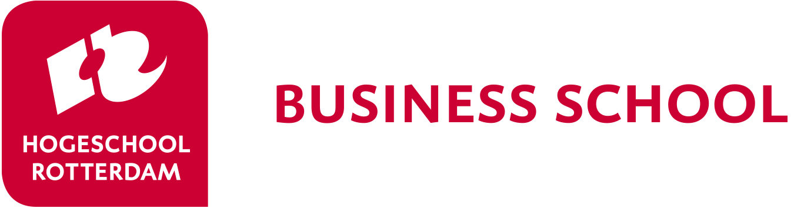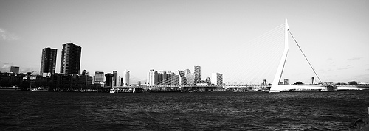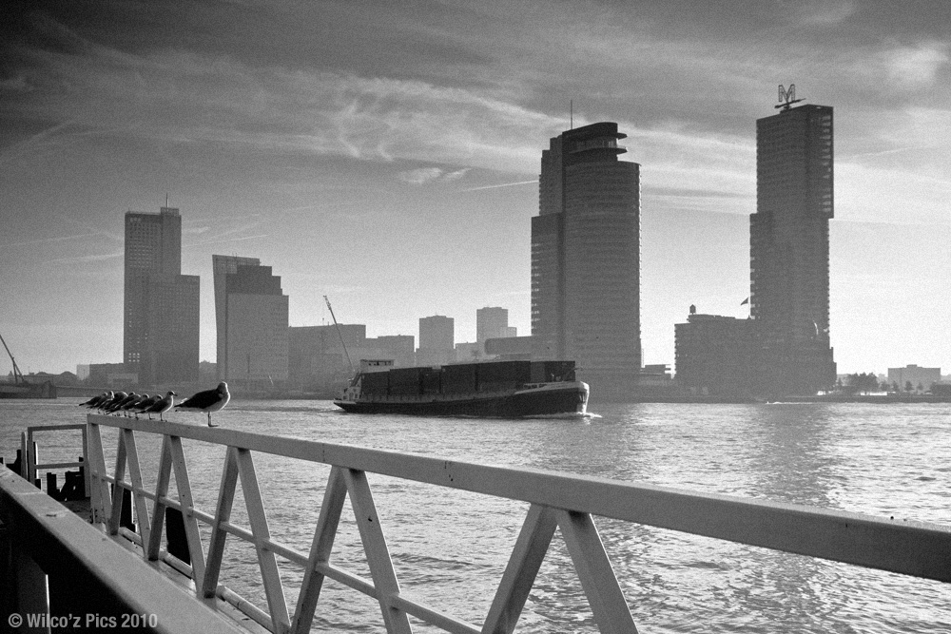

Rotterdam Business School

welcomes you to the

Rotterdam Business Week / BIP

8 – 12 April 2024

*Note*: the physical week is also the starting point for the BIP-students

*“When it comes to international business, Rotterdam is the place to be! Europe's biggest port, the financial and business heart of The Netherlands, many international companies, a multicultural city ... a true gateway to the rest of the world!”*

**Accommodation**

*You will stay in hostel ROOM in Rotterdam. The hostel is in the city centre and is easy accessible by public transportation.* [Hostel ROOM Rotterdam, Holland - #1 boutique hostel](https://www.roomrotterdam.nl/)

**Traveling during Business Week**

*On arrival, you will receive a public transportation card from the Dutch students; These public transportation cards will give you access to the bus, tram and metro in Rotterdam. There is enough money on the card to travel to and from the University. If you wish to use public transportation more often, you have to charge the card yourself. Please hand in the card at the end of the week.*

*Travel to the University*

*There will be 2 Dutch students staying in the hostel as well. They will accompany you to the university so you won’t get lost in the public transportation system of Rotterdam.*

**Coffee breaks**

*In order to get to know one another, it is common to share some food and/or drinks. To keep up the tradition we ask the students from each country to bring some food and/or drinks which are typical for their country and share them with the other students and lecturers.*

***What can you expect?***

*fun, new friendships, international experience!*

**Rotterdam, your hosting city**

*Rotterdam is ‘hot and happening’. According to the British Academy of Urbanism, Rotterdam is the best European city to live in. Rough Guides Travel placed Rotterdam in the top ten cities of the world you must see. Experience the city with its young, tolerant and open-minded population.*

*During the business week you will explore Rotterdam and students will organize a night out for you, so you can also experience the night life of this modern city.*

**Welcome!!**

*The Rotterdam Business Week might be a long time away. However, preparations go at full speed. This brochure gives you an overview of what you can expect from this week and/or BIP.*

## Arrival

## *Dutch students will contact you before the business week by email. They will make arrangements to guide you from the Central Train station in Rotterdam to the hostel when you arrive. In order to make an appointment about the time and place of your pick-up, the students will contact you at least two weeks before arrival by e-mail. Please make arrangements with the students to bring you to the hostel.*

## *If you come by car, let the students know as well. The hostel has no parking space, so you will have to park in a parking garage in the neighbourhood. This is expensive, but it is the safest way. During the week you can use public transportation.*

## *.*

**IMPORTANT EMAILS**

Application/questions:

[HRBS-international@hr.nl](mailto:HRBS-international@hr.nl)

Coordinator Business week:

[P.J.M.KOEVOET-SONNEVELD@HR.NL](mailto:P.J.M.KOEVOET-SONNEVELD@HR.NL)

D.M.M.BOUWMAN@HR.NL

**CONTACTS**

HRBS-International

Kralingse Zoom 91  
3063 ND Rotterdam  
The Netherlands

[www.rotterdamuas.com](http://www.rotterdamuas.com)

Rotterdam Business Week 2024



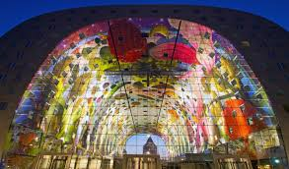

[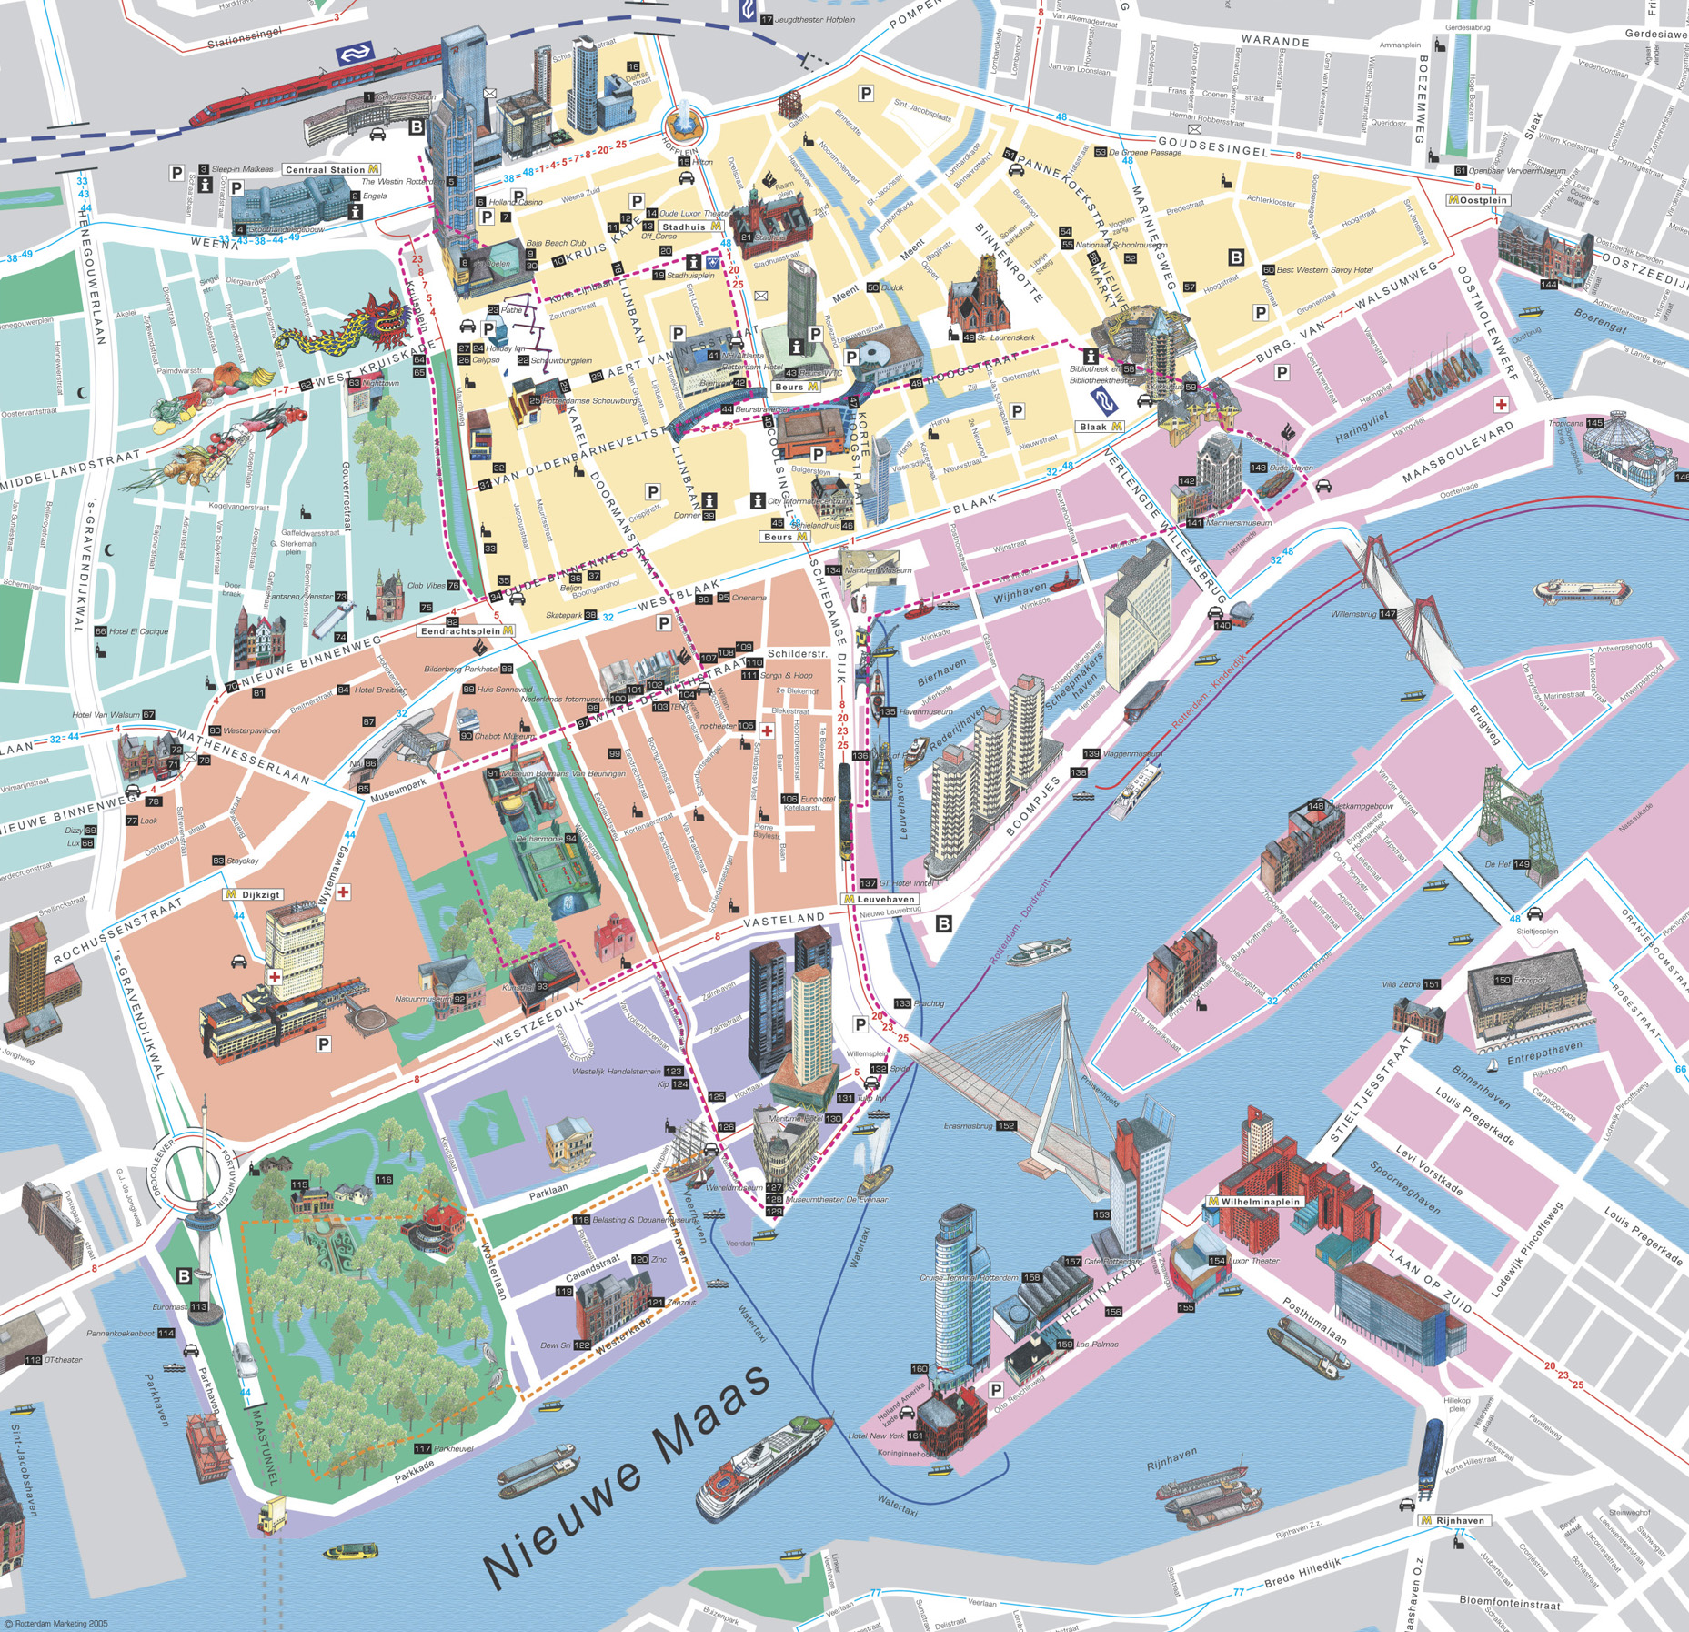](http://www.google.nl/url?sa=i&rct=j&q=&esrc=s&source=images&cd=&cad=rja&uact=8&ved=0ahUKEwiFyt-WoLbNAhXKvxQKHeoJAHgQjRwIBw&url=http://www.orangesmile.com/travelguide/rotterdam/city-maps.htm&psig=AFQjCNHIhitk53U97zPPUFaxOYF0WbQ1vQ&ust=1466499639167599)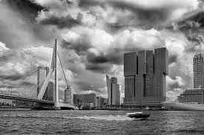

**Company visit:**

*Each student is part of a team and assigned to a real company. You will visit the company you work for on Wednesday morning.*

*(this is a formal company visit, the dress code is formal as well!)*

**The case competition**

## *This business week is about Risk Management. You and your team will be assigned to a real-life business case. Three companies will participate in the week. You will work in a small group on a risk analysis of one of the companies.*

## *At the end of the week you will be asked to present the risk analysis to a jury consisting of representatives of the business company.*

**Only for Students participating in the Blended Learning Programme (BIP):**

*Students participating in the BIP-programme will continue to work on the subject of Risk Management after this week online. The dates will be defined on a later date.*

**Student/ teacher dinner**

*Monday evening we organize an informal dinner for all participants.*

*For the teachers there is an additional dinner on Wednesday evening.*

**Pre-week assignment:**

*To get to know you, we also ask you to make a short film of 5 minutes about your country, the city, the university and yourself.*

*Deadline: the short film (or the link to it) should be emailed to* [*RBS-international@hr.nl*](mailto:RBS-international@hr.nl) *at 12th March 2024.*

**Work in international teams**

## *Students will work in groups of 5 or 6 participants. You will receive the case on Monday afternoon and start working on it right away. Students will be working in international groups so they will experience how it is to work with different cultures and in English (a challenge as well). In the schedule you will find the working hours of the students. The lecturers will be asked to monitor the groups.*

**Rotterdam**

## *Rotterdam is a modern city with a unique sky line. You will have a few hours of free time to explore the city of Rotterdam and its architectural buildings. Don’t forget to bring a camera/phone.*

Rotterdam Business Week 2024

|  |  |  |  |  |
| --- | --- | --- | --- | --- |
| Monday April 8 | Tuesday April 9 | Wednesday April 10 | Thursday April 11 | Friday April 12 |
|  | **Location : Kralingse Zoom 91, Rotterdam**  08.15 Pick-up at Hostel  09.00 Guest lecture Introduction Risk Management  10.00 Working on the case  11.00 – 11.15 Coffee break  12.00  **Presentation task 1** | 09.00 – 11.30  Consultancy at the Case Company.  12.00 Return to university | **Location : Kralingse Zoom 91, Rotterdam**  9.30 Working on the case/prepare final presentation.  11.00 – 11.15 coffee break  11.30  **Presentation task 3**  12.00 working on the case | **Location : Kralingse Zoom 91, Rotterdam**  09.00 Working on the presentations + voting on City Challenge  9.30: Signing Erasmus Documents    10.00 – 10.15 Coffee break  10.30 **Final** **Presentations**  11.45 jury case winner results  12.00 – 13.00  - winners photo competition  - certificates   * feedback * Students look back (pictures) * farewell |
| 12.30 Arrival of students at **Kralingse Zoom** | 12.30 – 13.30 Lunch | 12.00 – 13.00 Lunch | 12.30 – 13.30 Lunch | 13.00 – 14.00 Lunch (voluntary) |
| 12.45 Lunch at location  13.30 – 14.30 introduction of the week  Country presentation  Meet your team   * team building activities * tour/quiz through building   17.30: departure to city center  18.00 - 20.00  Student + lecturers dinner | 13.30 Working on the case  15.00 **Presentation task 2**  16.00 – 17.30 Cultural Specialties  *All countries present their local food/drink specialties*  Free program in the evening or student organized evening | 13.00 Working on the case  15.30- 15.45 Coffee break  16.15 **Presentation task 3**  17.15 Students free program in the evening  18.00 Lecturers dinner | Cultural Programme in Rotterdam   * nick name tour /foto competition   ?? something nice!!  Free program in the evening or student organized evening | 14.00 Departure |

Provisional Schedule Rotterdam Business Week 2024