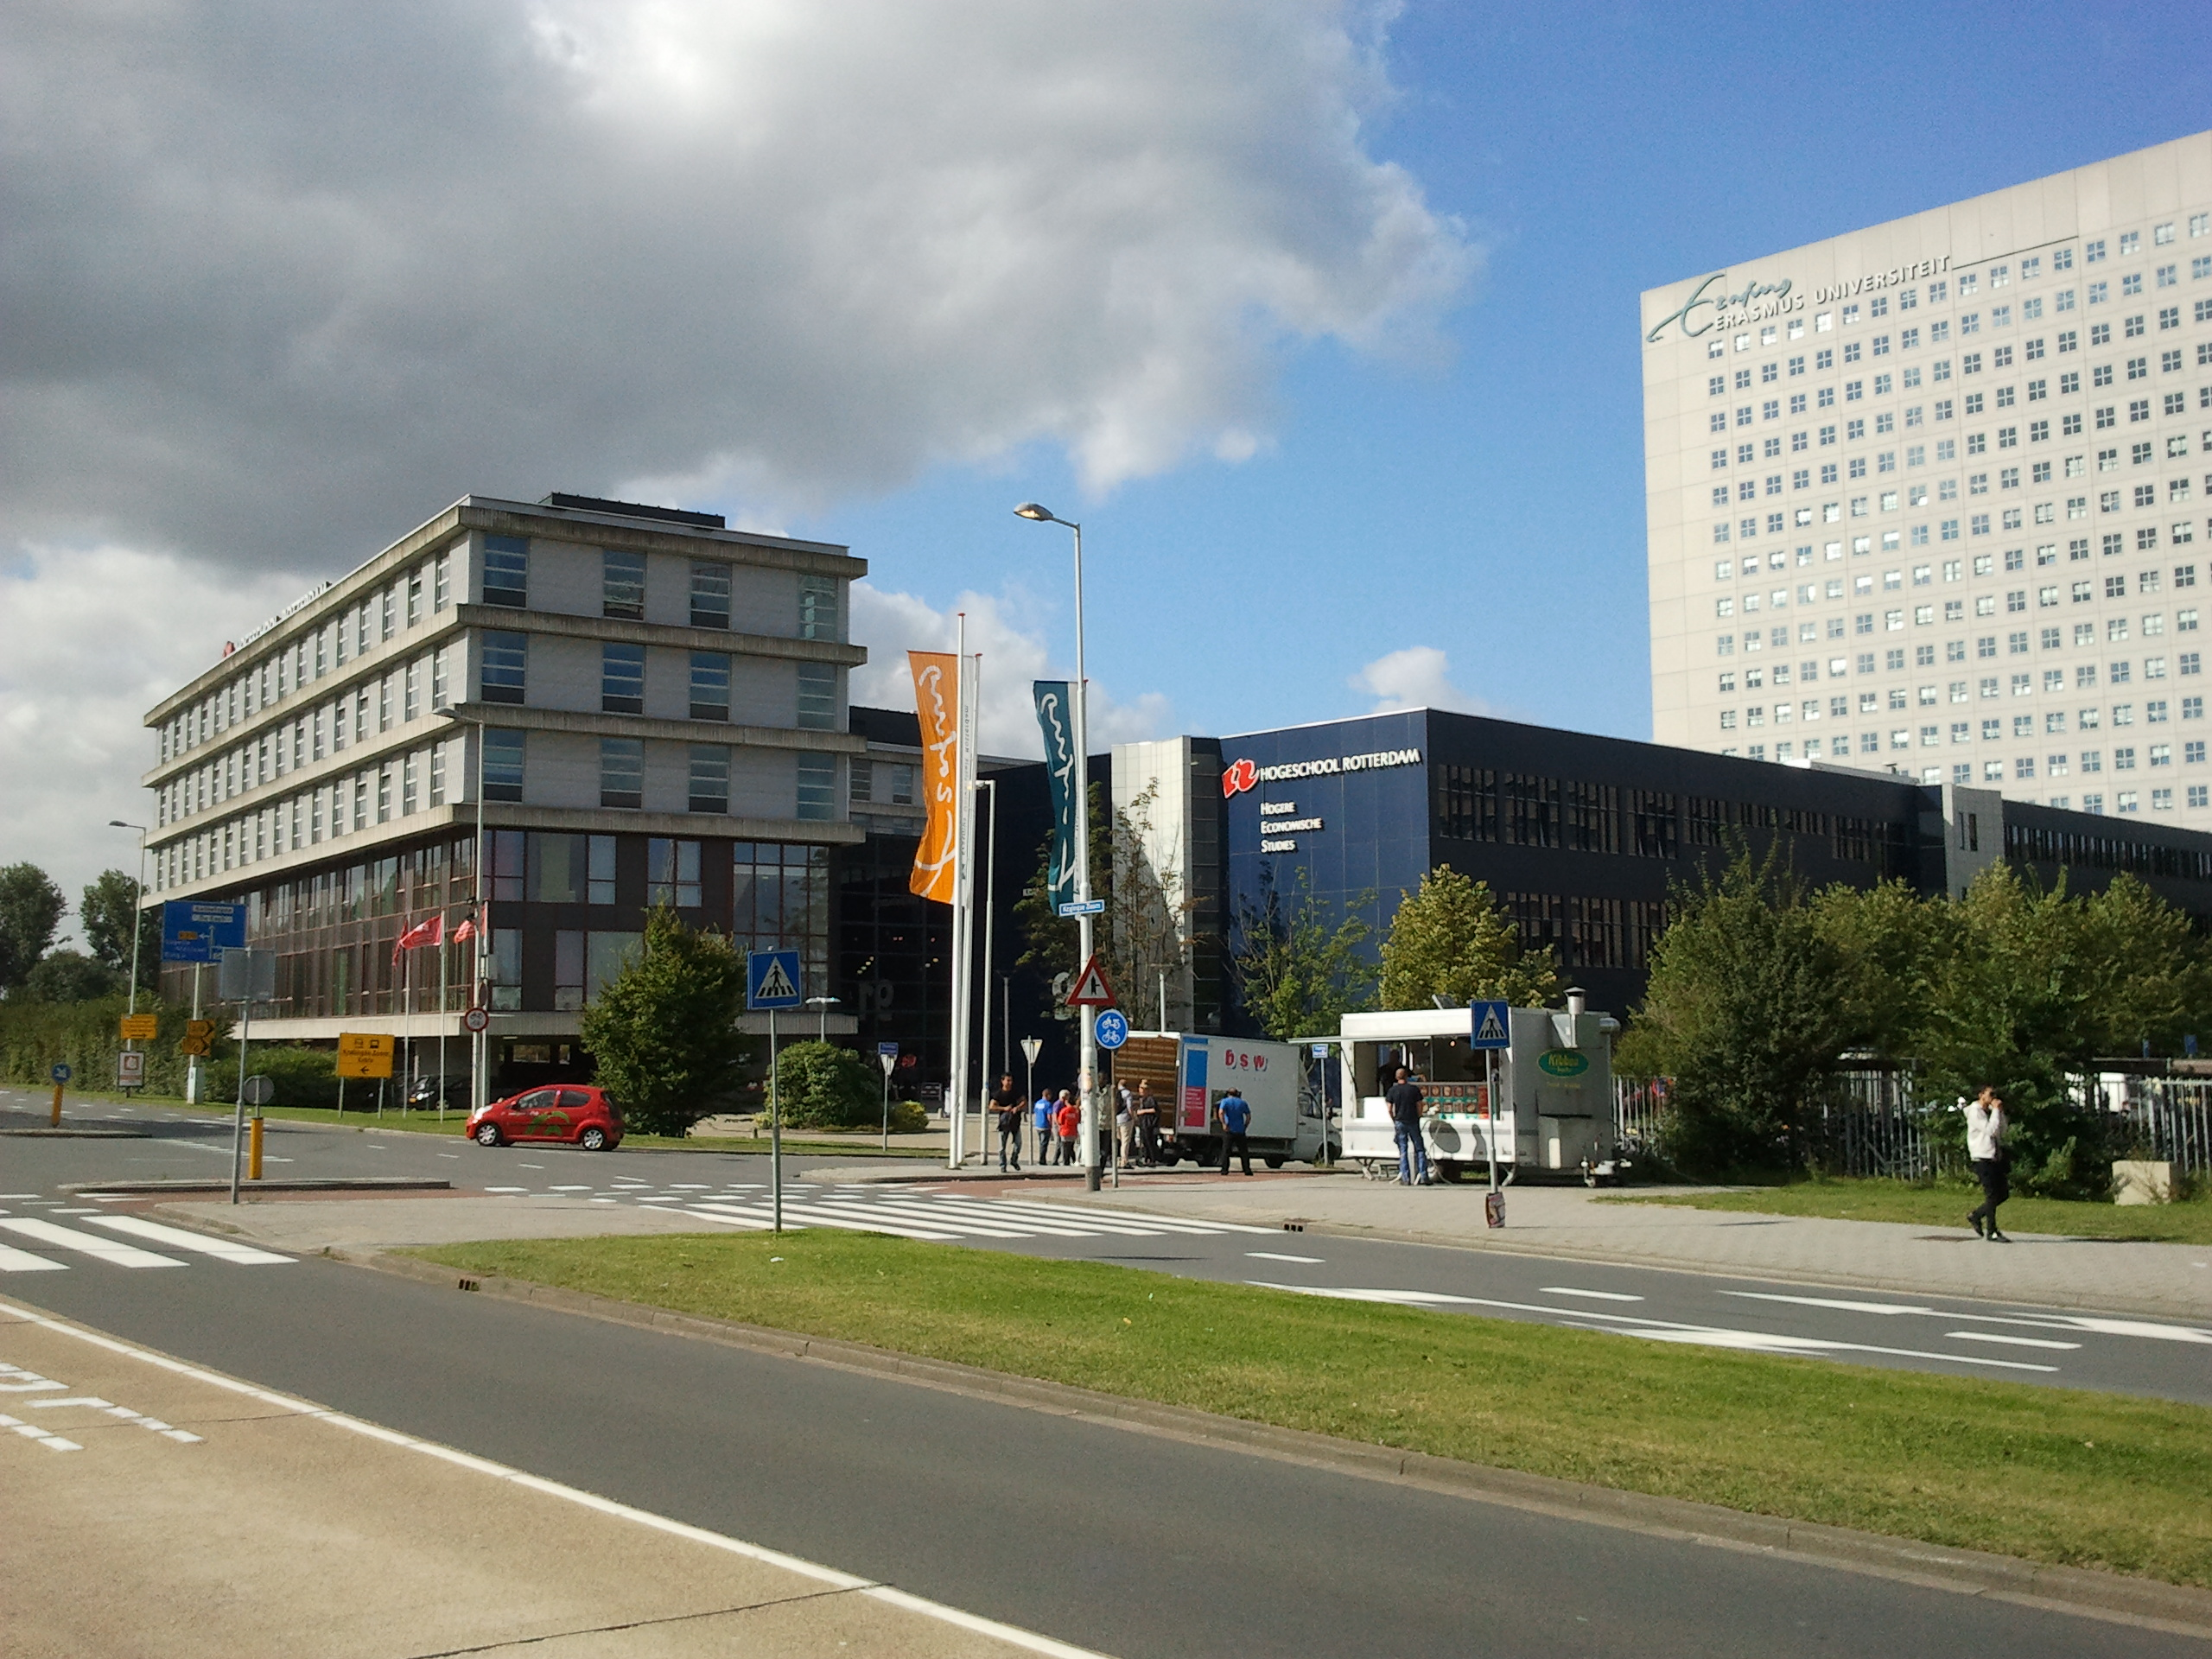

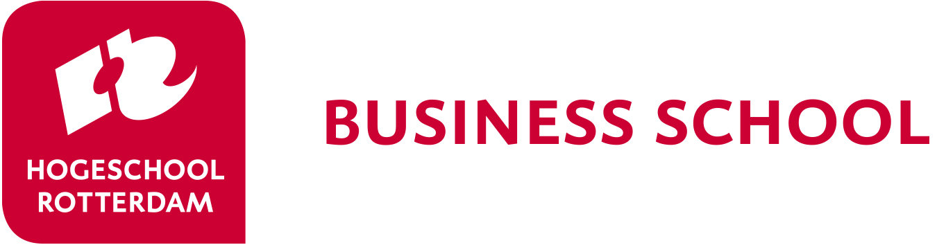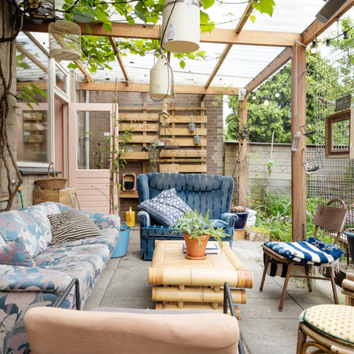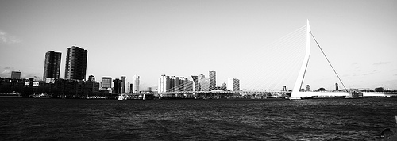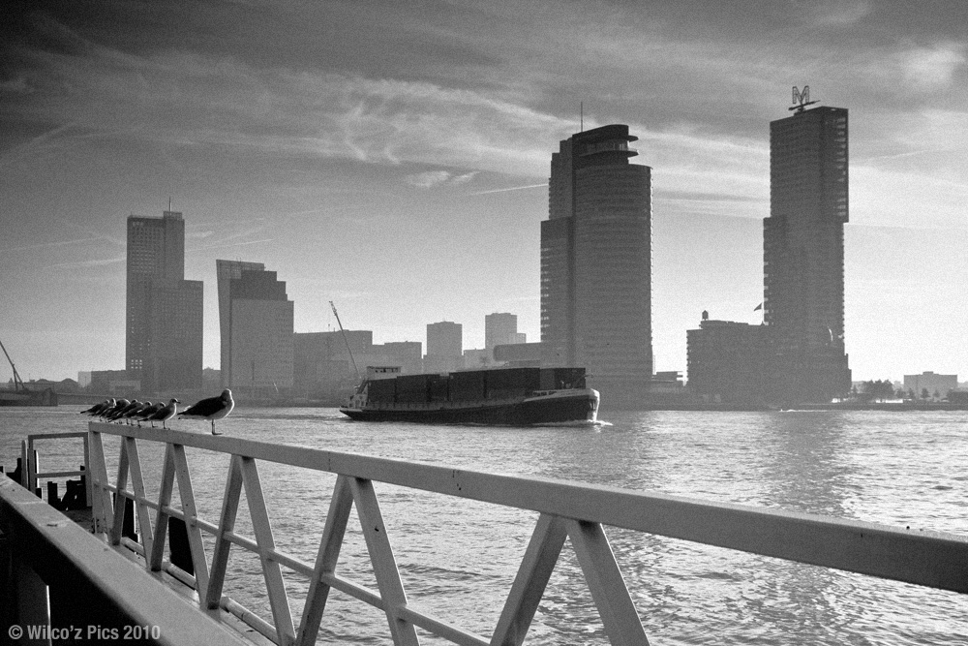

Rotterdam Business School

welcomes you to the

Rotterdam Business Week / BIP

22 – 26 May 2023

*Note*: the physical week is also the starting point for the BIP-students

*“When it comes to international business, Rotterdam is the place to be! Europe's biggest port, the financial and business heart of The Netherlands, many international companies, a multicultural city ... a true gateway to the rest of the world!”*

**Traveling during Business Week**

*On arrival, you will receive a public transportation card from the Dutch students; These public transportation cards will give you access to the bus, tram and metro in Rotterdam. There is enough money on the card to travel to and from the University. If you wish to use public transportation more often, you have to charge the card yourself. Please hand in the card at the end of the week.*

*Travel to the University*

*There will be 2 Dutch students staying in the hostel as well. They will accompany you to the university so you won’t get lost in the public transportation system of Rotterdam.*

**Coffee breaks**

*In order to get to know one another, it is common to share some food and/or drinks. Therefore we organize coffee breaks. To keep up the tradition we ask the students from each country to bring some food and/or drinks which are typical for their country and share them with the other students and lecturers.*

***What can you expect?***

*fun, new friendships, international experience!*

**Rotterdam, your hosting city**

*Rotterdam is ‘hot and happening’. According to the British Academy of Urbanism, Rotterdam is the best European city to live in. Rough Guides Travel placed Rotterdam in the top ten cities of the world you must see. Experience the city with its young, tolerant and open-minded population.*

*During the business week you will explore Rotterdam and students will organize a night out for you, so you can also experience the night life of this modern city.*

**Welcome!!**

*The May edition of the Rotterdam Business Week might be a long time away. However, preparations go at full speed. Although no guaranties can be given, we are preparing a live event in Rotterdam.*

**Accommodation**

*Later to be decided.*

*Reservations will be made from Monday till Friday. Breakfast is included.*

## Arrival

## *Dutch students will contact you before the business week by email. They will make arrangements to guide you from the Central Train station in Rotterdam to the hostel when you arrive. In order to make an appointment about the time and place of your pick-up, the students will contact you at least two weeks before arrival by e-mail. Please make arrangements with the students to bring you to the hostel.*

## *If you come by car, let the students know as well. The hostel has no parking space, so you will have to park in a parking garage in the neighbourhood. This is expensive, but it is the safest way. During the week you can use public transportation.*

## *.*

**IMPORTANT EMAILS**

Application/questions:

[HRBS-international@hr.nl](mailto:HRBS-international@hr.nl)

Coordinator Business week:

[P.J.M.KOEVOET-SONNEVELD@HR.NL](mailto:P.J.M.KOEVOET-SONNEVELD@HR.NL)

D.M.M.BOUWMAN@HR.NL

**CONTACTS**

IFM-International

Kralingse Zoom 91  
3063 ND Rotterdam  
The Netherlands

[www.rotterdamuas.com](http://www.rotterdamuas.com)

Rotterdam Business Week 2023



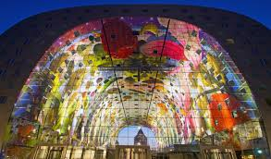

[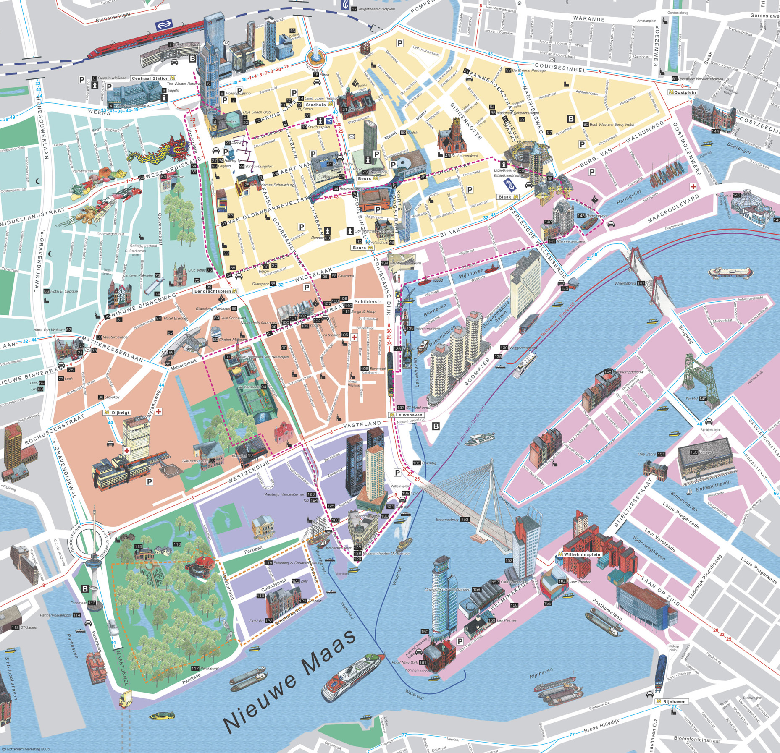](http://www.google.nl/url?sa=i&rct=j&q=&esrc=s&source=images&cd=&cad=rja&uact=8&ved=0ahUKEwiFyt-WoLbNAhXKvxQKHeoJAHgQjRwIBw&url=http://www.orangesmile.com/travelguide/rotterdam/city-maps.htm&psig=AFQjCNHIhitk53U97zPPUFaxOYF0WbQ1vQ&ust=1466499639167599)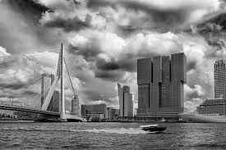

**Only for Students participating in the Blended Learning Programme (BIP):**

*Students participating in the BIP-programme will continue to work on the subject of Risk Management after this week online. They will take part in online groups to play a Simulation Game. An extra set of online moments will be between 30th May and 8th of June (exact dates will follow)*

**Student/ teacher dinner**

*Monday evening we organize an informal dinner.*

*For the teachers there is also a dinner on Wednesday evening.*

**Pre-week assignment:**

*To get to know you, we also ask you to make a short film of 5 minutes about your country, the city, the university and yourself.*

*Deadline: the short film (or the link to it) should be emailed to* [*HRBS-international@hr.nl*](mailto:HRBS-international@hr.nl) *at 12th May 2023.*

**Company visit:**

*Each student is part of a team and assigned to a company. You will visit the company you work for on Wednesday morning.*

*(this is a formal company visit, the dress code is formal as well!)*

**Work in international teams**

## *Students are split up in groups of 5 or 6 participants. They will receive the case on Monday afternoon and start working on it right away. Students will be working in international groups so they will experience how it is to work with different cultures and in English (a challenge as well). In the schedule you will find the working hours of the students. The lecturers will be asked to help the groups.*

**The case competition**

## *This business week is about Risk Management. You and your team will be assigned to a real-life business case. Several companies will participate in the week. At the end of the week you will be asked present a risk analysis to a jury consisting of teachers and a representative of the business company.*

**Rotterdam**

## *Rotterdam is a modern city with a unique sky line. You will have a few hours of free time to explore the city of Rotterdam and its architectural buildings. Don’t forget to bring a camera/phone.*

Rotterdam Business Week 2023

|  |  |  |  |  |
| --- | --- | --- | --- | --- |
| Monday May 22 | Tuesday May 23 | Wednesday May 24 | Thursday May 25 | Friday May 26 |
|  | **Location : Kralingse Zoom 91**  08.00 Pick-up at Hostel  08.30 Guest lecture Introduction Risk Management  09.15 Working on the case  11.00 Coffee break  *Presentation & Culinary specialties :*  11.30 **Presentation task 1**  12.00 Working on the case | 08.30 Consultancy at the Case Company.  11.00 Coffee break  11.30 Working on the case | **Location : Kralingse Zoom 91**  9.30 Working on the case/prepare final presentation. | **Location : Kralingse Zoom 91**  09.00 Working on the presentations    10.00 Coffee break  *Culinary specialties :*  10.30 **Final** **Presentations**  12.00 – 13.00 Jury results & Prize winners   * certificates * feedback * Students look back (pictures) * farewell |
| 12.30 Arrival of students at **location TBD** | 13.00 – 14.00 Lunch | 13.00 – 14.00 Lunch | 12.00 Lunch | 13.00 – 14.00 Lunch (voluntary) |
| 12.45 Lunch at location  13.30 – 14.30 introduction of the week  Country presentation  Meet your team  14.30 – 18.00  assignment in city centre  18.00 Studentdinner  Free program in the evening | 14.00 Working on the case  15.00 Coffee break  *Presentation & Culinary specialties:*  15.30 Working on the case  16.30 **Presentation task 2**  Free program in the evening | 14.00 Working on the case  15.30 Coffee break  *Culinary specialties :*  16.15 **Presentation task 3**  17.15 free program in the evening | Cultural Programme  14.00 Activity in Amsterdam  15.00 Amsterdam  ***Free programme***  19.00 **Amsterdam** boat trip  20.30 Transport back to Rotterdam, directly after boat trip  21.30 Arrival in Rotterdam | 14.00 Departure |

Provisional Schedule Rotterdam Business Week 2023