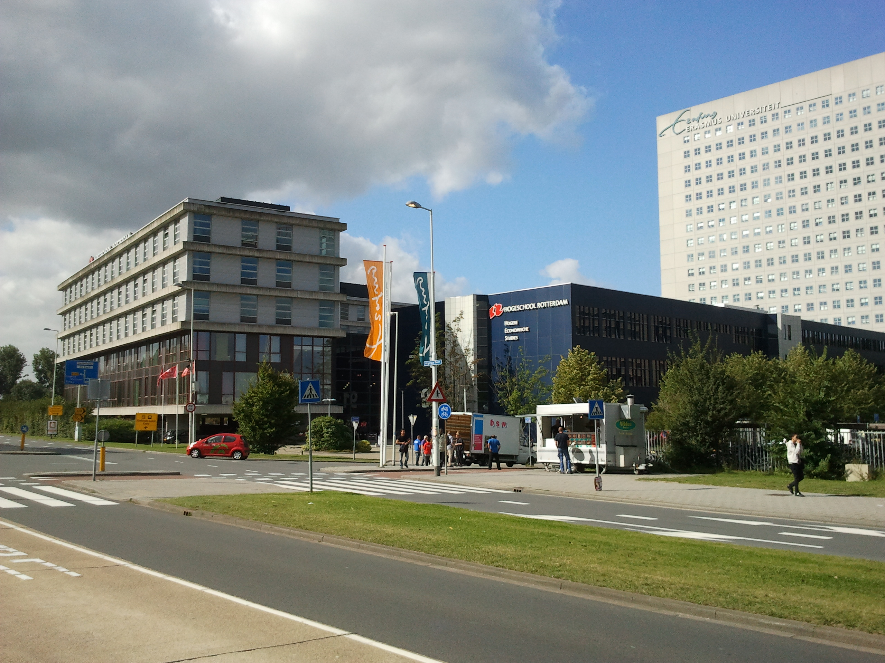

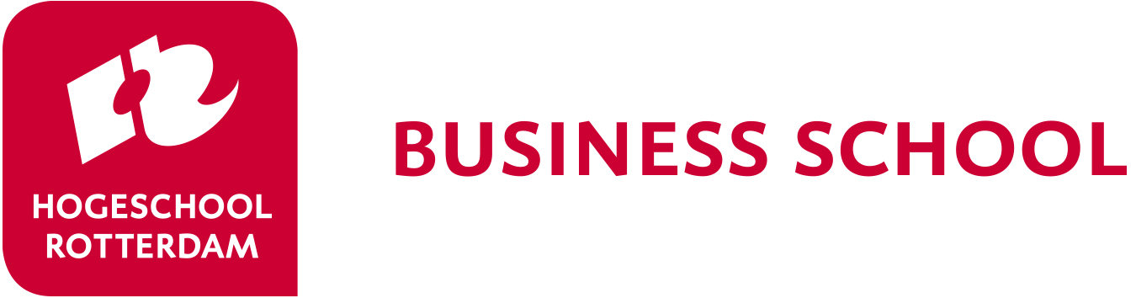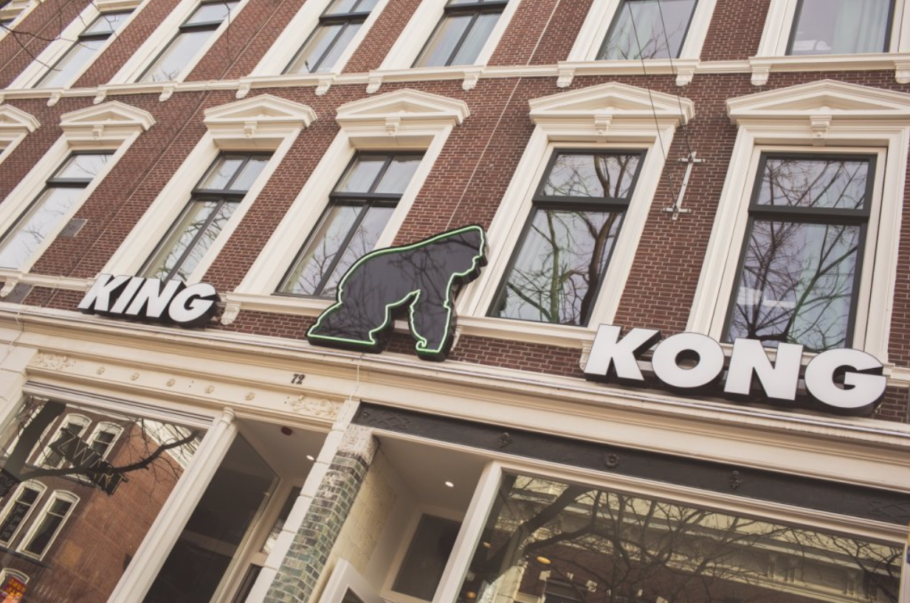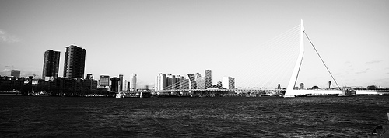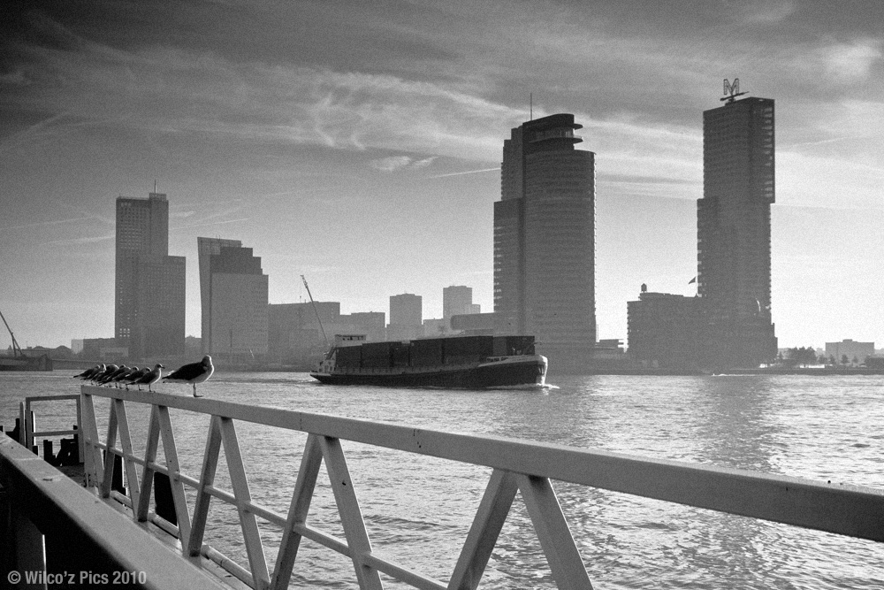

Rotterdam Business School

welcomes you to the

Rotterdam Business Week

9 – 13 May 2022

*Note*: the physical week is also the starting point for the BIP-students

*“When it comes to international business, Rotterdam is the place to be! Europe's biggest port, the financial and business heart of The Netherlands, many international companies, a multicultural city ... a true gateway to the rest of the world!”*

**Student/teacher dinner**

*Monday evening we organize an informal dinner.*

*For the teachers there is also a dinner on Wednesday evening.*

**Accommodation**

*King Kong Hostel is located in the centre of Rotterdam. It is close to everything. The Witte de Withstraat is hip and happening, with all kind of trendy bars, restaurants and art. Reservations are made from Monday till Friday. Breakfast is included.*

**Traveling during Business Week**

*On arrival, you will receive a public transportation card from the Dutch students; These public transportation cards will give you access to the bus, tram and metro in Rotterdam. There is enough money on the card to travel to and from the University. If you wish to use public transportation more often, you have to charge the card yourself. Please hand in the card at the end of the week.*

*Travel to the University*

*There will be 2 Dutch students staying in the hostel as well. They will accompany you to the university so you won’t get lost in the public transportation system of Rotterdam.*

***What can you expect?***

*fun, new friendships, international experience!*

**Rotterdam, your hosting city**

*Rotterdam is ‘hot and happening’. According to the British Academy of Urbanism, Rotterdam is the best European city to live in. Rough Guides Travel placed Rotterdam in the top ten cities of the world you must see. Experience the city with its young, tolerant and open-minded population.*

*During the business week you will explore Rotterdam and students will organize a night out for you, so you can also experience the night life of this modern city.*

**Coffee breaks**

*In order to get to know one another, it is common to share some food and/or drinks. Therefore we organize coffee breaks. To keep up the tradition we ask the students from each country to bring some food and/or drinks which are typical for their country and share them with the other students and lecturers.*

## Arrival

## *Dutch students will contact you before the business week by email. They will make arrangements to guide you from the Central Train station in Rotterdam to the hostel when you arrive. In order to make an appointment about the time and place of your pick-up, the students will contact you at least two weeks before arrival by e-mail. Please make arrangements with the students to bring you to the hostel.*

## *If you come by car, let the students know as well. The hostel has no parking space, so you will have to park in a parking garage in the neighbourhood. This is expensive, but it is the safest way. During the week you can use public transportation.*

## *.*

**Welcome!!**

*The May edition of the Rotterdam Business Week might be a long time away. However, preparations go at full speed. Although no guaranties can be given, we are preparing a live event in Rotterdam.*

**IMPORTANT EMAILS**

Application/questions:

[Ifm-international@hr.nl](mailto:Ifm-international@hr.nl)

Coordinator Business week:  
[R.J.DU.CHATINIER@HR.NL](mailto:R.J.DU.CHATINIER@HR.NL)

P.J.M.KOEVOET-SONNEVELD@HR.NL

**CONTACTS**

IFM-International

Kralingse Zoom 91  
3063 ND Rotterdam  
The Netherlands

[www.rotterdamuas.com](http://www.rotterdamuas.com)

Rotterdam Business Week 2022



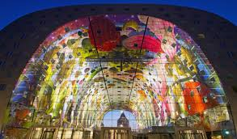

[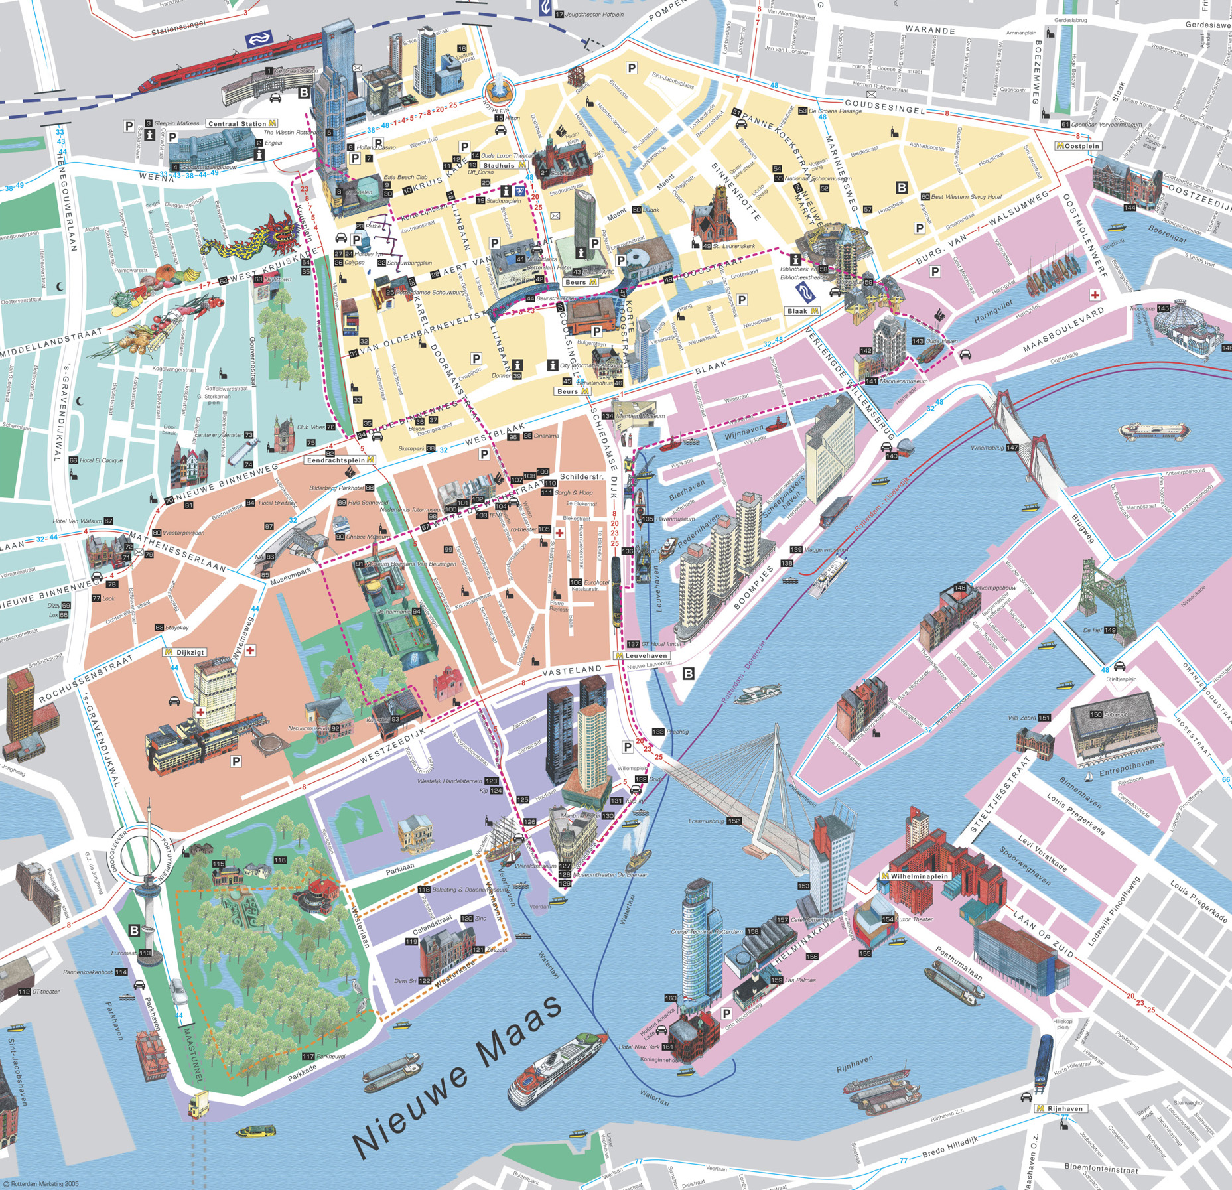](http://www.google.nl/url?sa=i&rct=j&q=&esrc=s&source=images&cd=&cad=rja&uact=8&ved=0ahUKEwiFyt-WoLbNAhXKvxQKHeoJAHgQjRwIBw&url=http://www.orangesmile.com/travelguide/rotterdam/city-maps.htm&psig=AFQjCNHIhitk53U97zPPUFaxOYF0WbQ1vQ&ust=1466499639167599)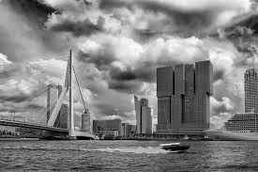

**Only for Students participating in the Blended Learning Programme (BIP):**

*Students participating in the BIP-programme will continue to work on the subject of Risk Management after this week online. They will take part in online groups to play a Simulation Game. An extra set of online moments will be schedueld in after 13th May.*

Risk Management Simulation Game  Doclogistics

Students are tasked with risk management for Doclogistics, a company that handles shipping for other companies. To complete their risk management task they have to use several steps of the risk management process. Their goal is to make efficient use of risk management resources. The resources they can use are the combined costs of control measures they purchase and the impact of risks that still do occur. Efficient use of these resources means these combined costs are kept low.

**Pre-week assignment:**

*To get to know you, we also ask you to make a short film of 5 minutes about your country, the city, the university and yourself.*

*Deadline: the short film (or the link to it) should be emailed to* [*HRBS-international@hr.nl*](mailto:HRBS-international@hr.nl) *at 2nd May 2022.*

**Company visit:**

*Each student is part of a team and assigned to a company. You will visit the company you work for on Wednesday morning.*

*(this is a formal company visit, the dress code is formal as well!)*

**The case competition**

## *This business week is about Risk Management. You and your team will be assigned to a real-life business case. Several companies will participate in the week. At the end of the week you will be asked present a risk analysis to a jury consisting of teachers and a representative of the business company.*

**Work in international teams**

## *Students are split up in groups of 5 or 6 participants. They will receive the case on Monday afternoon and start working on it right away. Students will be working in international groups so they will experience how it is to work with different cultures and in English (a challenge as well). In the schedule you will find the working hours of the students. The lecturers will be asked to help the groups.*

[Grab your reader’s attention with a great quote from the document or use this space to emphasize a key point. To place this text box anywhere on the page, just drag it.]

**Rotterdam**

## *Rotterdam is a modern city with a unique sky line. You will have a few hours of free time to explore the city of Rotterdam and its architectural buildings. Don’t forget to bring a camera/phone.*

Rotterdam Business Week 2022

|  |  |  |  |  |
| --- | --- | --- | --- | --- |
| Monday May 9 | Tuesday May 10 | Wednesday May 11 | Thursday May 12 | Friday May 13 |
| 12.00 Opening at **location**……. | **Location : Kralingse Zoom 91**  08.00 Pick-up at Hostel  08.30 Guest lecture Introduction Risk Management  09.15 Working on the case  11.00 Coffee break  *Presentation & Culinary specialties :*  11.30 **Presentation task 1**  12.00 Working on the case | 08.30 Consultancy at the Case Company.  11.00 Coffee break  11.30 Working on the case | **Location : Kralingse Zoom 91**  9.30 Working on the case/prepare final presentation. | **Location : Kralingse Zoom 91**  09.00 Working on the presentations    10.00 Coffee break  *Culinary specialties :*  10.30 **Final** **Presentations**  12.00 – 13.00 Jury results & Prize winners   * certificates * feedback * Students look back (pictures) * farewell |
| 12.45 Lunch at location | 13.00 – 14.00 Lunch | 13.00 – 14.00 Lunch | 12.00 Lunch | 13.00 – 14.00 Lunch |
| 13.30 – 14.30 Country presentation of…….    14.30 – 15.30 Guest Lecture  15.30 – 18.00  assignment in city centre  18.00 Dinner  Free programme in the evening | 14.00 Working on the case  15.00 Coffee break  *Presentation & Culinary specialties:*  15.30 Working on the case  16.30 **Presentation task 2**  17.30 Dutch evening - activity organised by the Dutch Students | 14.00 Working on the case  15.30 Coffee break  *Culinary specialties :*  16.15 **Presentation task 3**  17.15 free program in the evening | Cultural Programme  14.00 Company visit: Amsterdam Stock Exchange  15.00 Amsterdam  ***Free programme***  19.00 **Amsterdam** boat trip  20.30 Transport back to Rotterdam, directly after boat trip  21.30 Arrival in Rotterdam | 14.00 Departure |

Provisional Schedule Rotterdam Business Week 2022