

International Marketing Week in Valencia, Spain
Universidad Europea de Valencia

Arriving on Sunday, February 24th and leaving after the group presentations at 14:00 on Friday, March 1st , 2019

Develop a Strategic Marketing Plan for a Winery
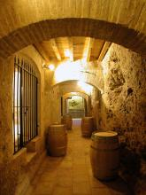

Practical information for students and teachers

International Marketing Week at the Universidad Europea de Valencia

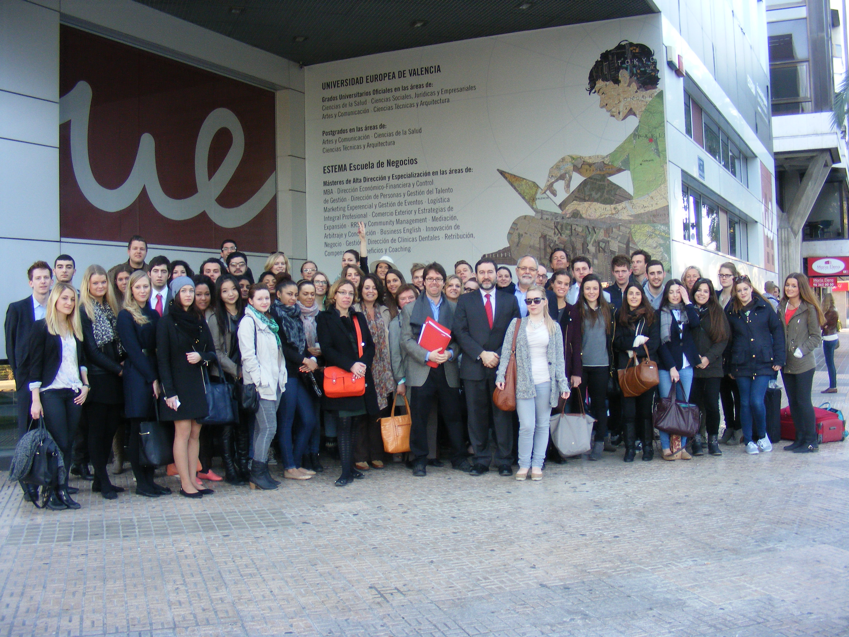

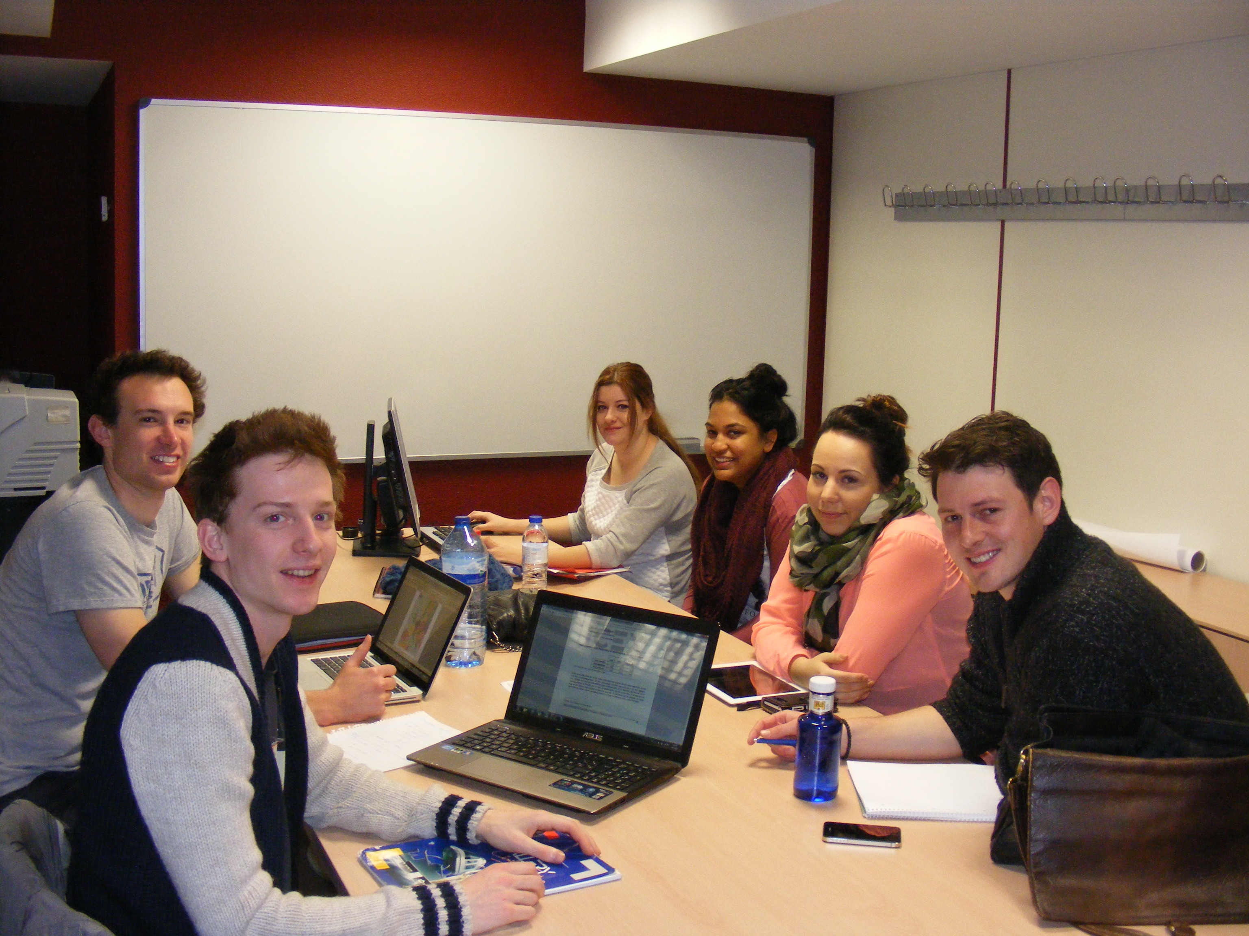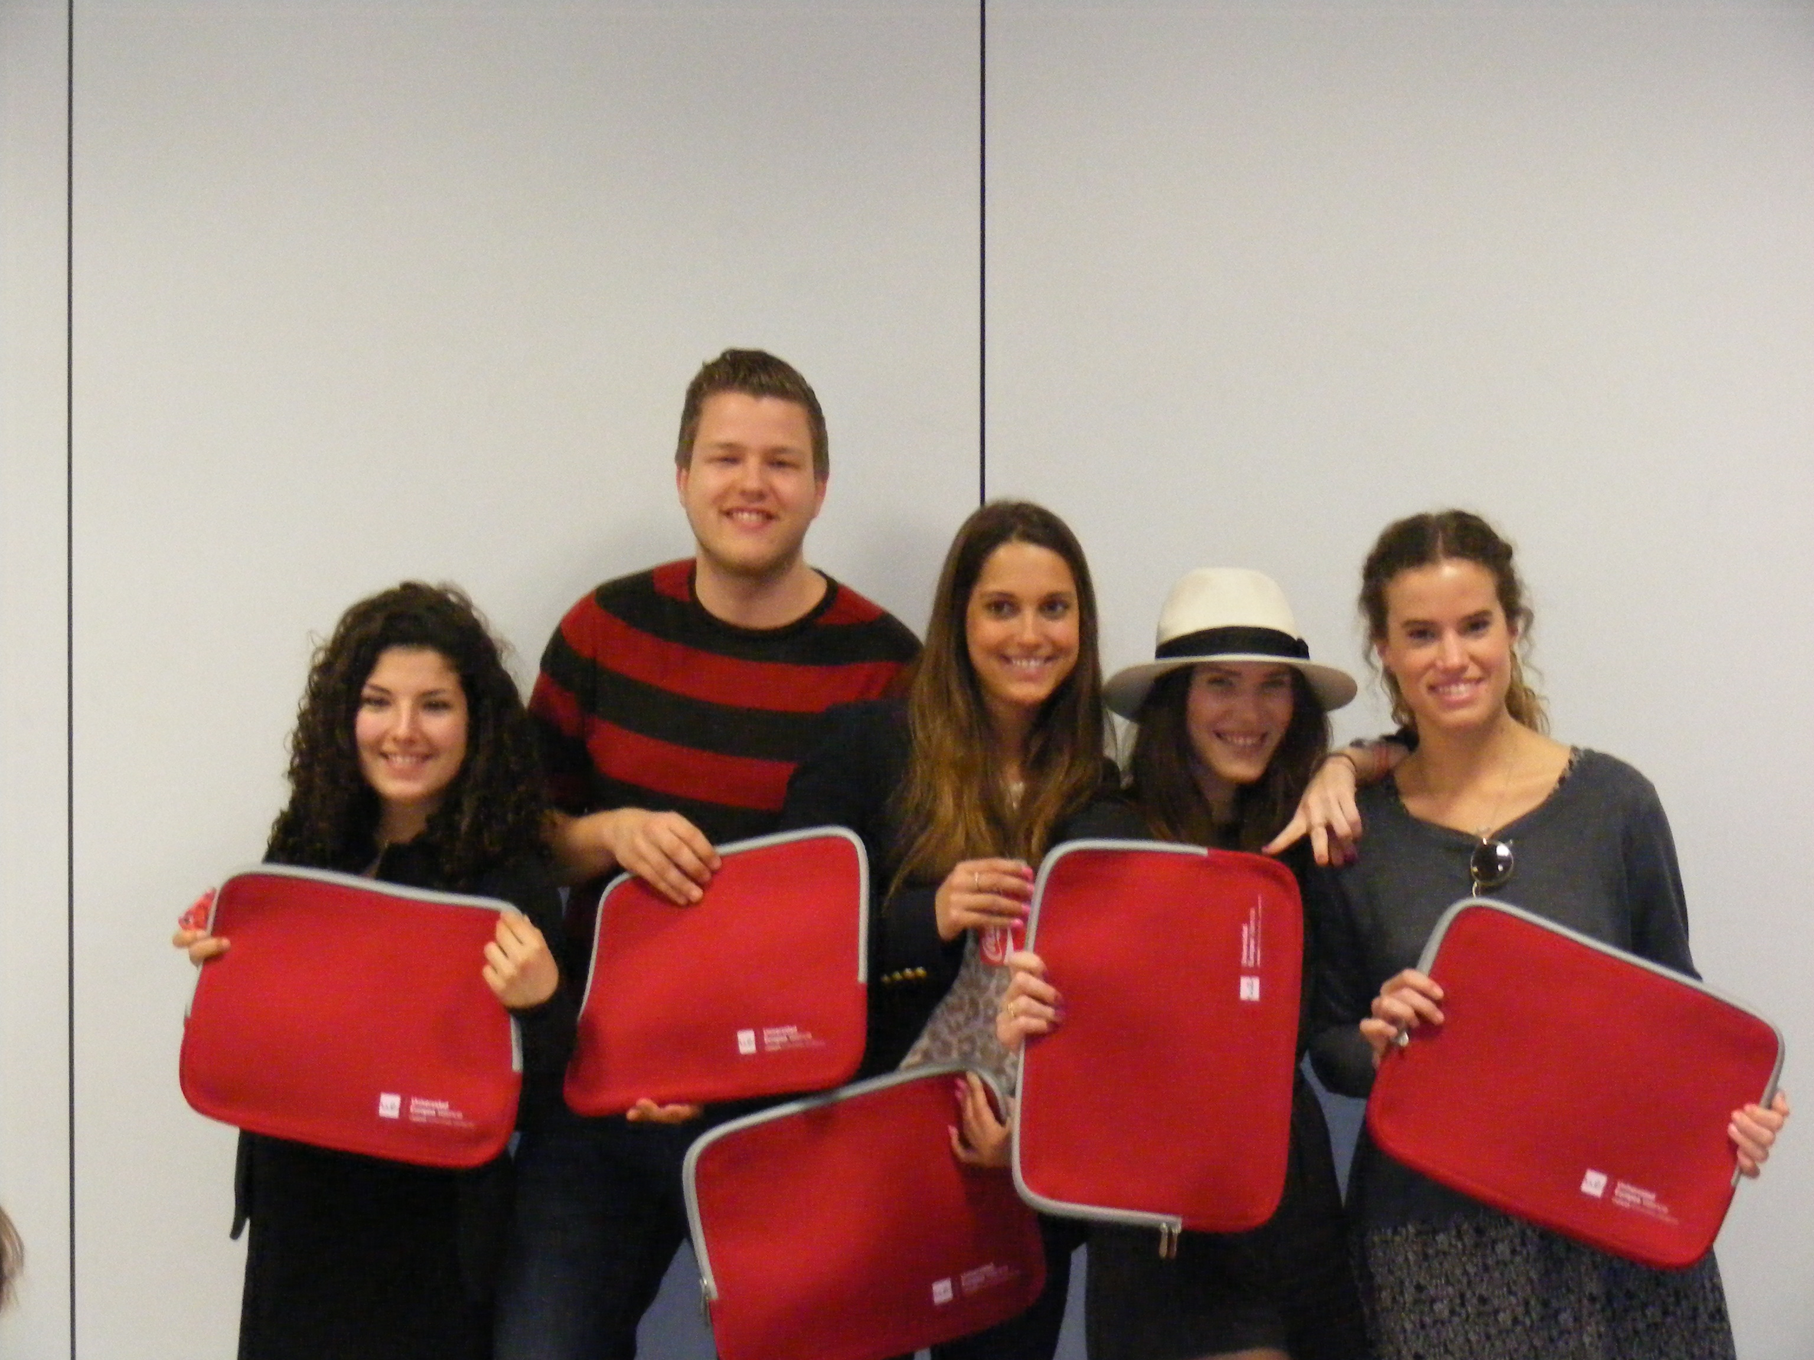

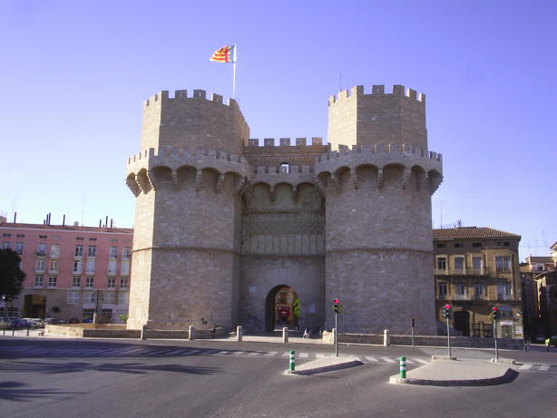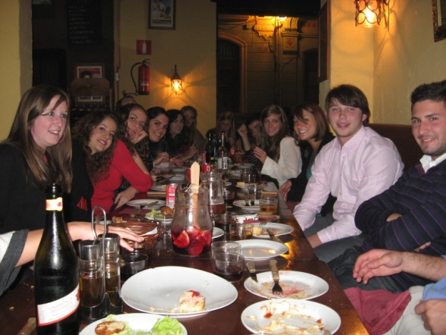

Contact information:

Universidad Europea de Valencia
Paseo de la Alameda, 7, Bajo
46010 Valencia

Contact: Dr. Stan McDaniel

Phone.: +34 960452832
Fax: +34 961318189

Stan.mcdaniel@universidadeuropea.es

http://valencia.universidadeuropea.es/

Workshop

This workshop will give you an excellent opportunity to put what you have studied about Marketing to work! What better place to learn about the art of winemaking than in Spain? You and your team members will be challenged to come up with the best strategic marketing plan for a winery. After visiting wine country, just an hour from the city of Valencia, seeing first-hand the process of making wine and cava, observing and living the local culture where wine is not thought of as “drinking” but as part of Spanish life and participating in the Mediterranean way of life, you are sure to be more creative with your marketing plan. Each day will be a new experience as you come closer to your final product. Your team will be composed of students just like yourself from a range of different countries – Finland, Denmark, France, Germany, Austria, Belgium, Holland, Spain and Latvia, all using one common language (English) to reach their goal. There will be teachers on hand to give you help when needed with your progress and your marketing plans. Live, enjoy, learn and practice your marketing skills in the beautiful Mediterranean city of Valencia!

Pre-departure assignment
In order to get you interested in the project and learn about wine before coming to Valencia, about two weeks before departure you will be sent some readings and an assignment to complete.
The first day will be a busy one: there will be a welcoming session, and then we will set off to wine country by bus. After lunch, there will be a guided tour of Valencia. You can see by the daily program which follows that there is a good balance between leisure and work (“the Spanish way”).

Program- INTERNATIONAL MARKETING WEEK VALENCIA
February 24th – March 1st , 2019

Sunday, February 24, 2016
Arrival to Valencia and go to the Hostal Penalty (www.hostalpenalty.com) located right behind the football stadium. If you arrive to Valencia by plane, you can take a metro from the airport terminal which leaves you just one block from the hostel! The hostel is a 20-minute walk to the University.
Evening free to explore the city.
Programmed activities for Monday, February 25
- A representative from the university will meet the students in the lobby of the hostel and you will walk to the university.
- Official welcome.
- Students will give a short presentation of their home universities (power point)
- University Tour
- Leave by bus to travel to wine country – 1 hour distance.
- You will have the opportunity to taste wine and cava.
- A guided tour of a winery: processing, packaging, visit the vineyards, etc. There will be a question-answer period at the end of the tour. You may purchase wine at the winery´s shop.
- Guided tour of the historical part of Valencia.
Tuesday, February 26
- Students will be informed of the main goals and structure of the contest.
- Formation of the teams
- Selection of the market and target (including definition of the market, analysis of competitors, etc.).
- Developing the product (positioning, brand, name, proposed value, points of parity, points of difference).
- SWOT Analysis (using the winery you visited as a framework)
- Go with the Spanish students to the center of Valencia to experience the Mascletá.
- Tapas dinner at the best tapas restaurant in Valencia: Jamón Jamón
Wednesday, February 27
- Price fixing (including different prices in account of the format).
- Developing the distribution channel (design, members of the channel, objectives).
- Defining price policy (including different margins in account of the different distributors, discounts).
Thursday, February 28

- The marketing communications plan (including objectives, creative concept, tagline, creativity).
- Media planning and tools.
- Defining special actions (public relations, presentations at Wine Fairs, etc.)
- Night out with the Spanish students.
Friday, March 1

- Teams will prepare their presentations.
- Each team will have a 15 minutes power point presentation to present their project.
- Award deliberation
- Award giving. Your certificates will be emailed to you.
Departures

Spanish Time

Everything in Spain is done much later than in other countries. In order to “go with the flow”, here are some sample timetables which will help you “be Spanish” for a week:

Breakfast: taken at the same time as any other country, but very light (café con leche, and a roll or pastry). Breakfast is included at the Hostel.

Lunch: we have programmed the lunches for 13:00, which, by Spanish standards is quite early (but we know you will be hungry). A “normal” Spanish lunchtime is anywhere from 14:00 – 15:00

Dinner: from 21:30-22:00.

Going out: Bars and discothèques will start filling up any time after midnight or even later.

Visit to Wine Country and a Winery: A Key Field Trip
The visit is a key part of the workshop as it will give the students a “feeling” for wine and its importance in Spanish culture. With the experience and knowledge acquired during this visit, the students will be better prepared to carry out their projects successfully.

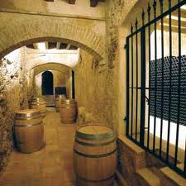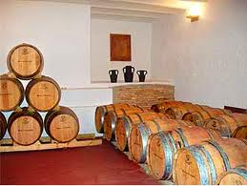

Leisure Program

Guided Tour of Valencia
Students will be taken through historical Valencia – the most beautiful part of the city.
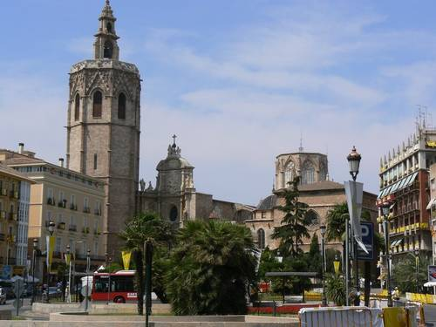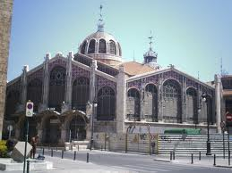

Tapas Evening
Tapas are a Spanish tradition, and we would like the students to taste the best tapas in town at Jamón, Jamón in the old part of Valencia.

Night out with Spanish Students
“Spanish people seem to never sleep”. Save your energy for this evening event. A good time is guaranteed and you may even learn a few words of Spanish!

Recommended optional activity (at extra cost)

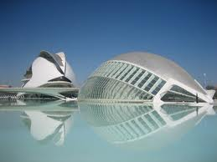

The famous City of Arts and Sciences (http://www.cac.es/?languageId=1) is a unique complex which you have to see to believe. You should not leave Valencia without at least having walked around the buildings – absolutely amazing.

Participation Fees and Registration
The participation fees for the International Marketing Week are 230 Euros per student. This price includes
- Accommodation (double room, or, in a few cases, triple room) for five nights (Sunday, February 24th to Friday, March 1st (after 14:00),
- 5 breakfasts,
- 4 lunches,
- A tapas dinner in the old quarter of Valencia,
- A guided tour of historical Valencia,
- A field trip to wine country and a winery (included is a wine tasting session) and the workshop sessions from Monday through Friday.

Each student must participate in the whole program: from arrival on Sunday, February 25, until after the Team Presentations on Friday, March 1.
In order to participate in the International Marketing Week in Valencia, please complete the attached registration form and return it to the responsible professor or lecturer of your university before January 15TH, 2019
Method of payment: you are to pay the participation fees (230 Euros) to your home institution (consult your university on how they prefer to receive the money) and they will transfer the money to the Universidad Europea de Valencia.

Accommodation

Accommodation will be at the Hostal Penalty (http://www.hostalpenalty.com/) which is a 20-minute walk from the university and a 20-minute walk to downtown Valencia. The hostal can be easily reached by from Valencia´s airport (instructions will be sent before coming to Valencia). IMPORTANT: If you need to extend your stay or arrive earlier, please contact the hostel directly: reservas@hostalpenalty.com

Arrival
Before coming to Valencia, detailed instructions will be sent to the students on how to get to the hostel.

What to bring
- Casual clothes: check the weather and temperature for Valencia on the internet. Weather can vary during the latter part of February-early March, from warm to cool.
- Some money for your spare time
- Laptop – if you have one

