International Business week – Project Management 2019

Venue: BA School of Business and Finance (SBF),
K. Valdemara Street 161, Riga, Latvia
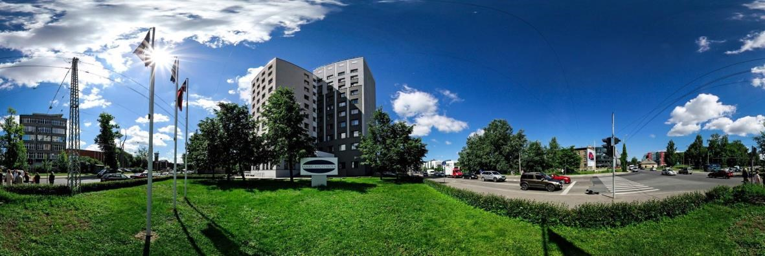
When: 25.03.2019 – 29.03.2019
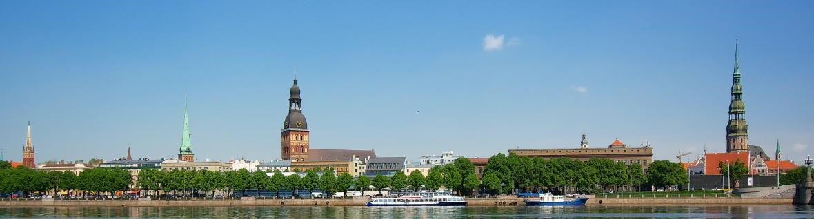
Who: Students from whole Europe and more
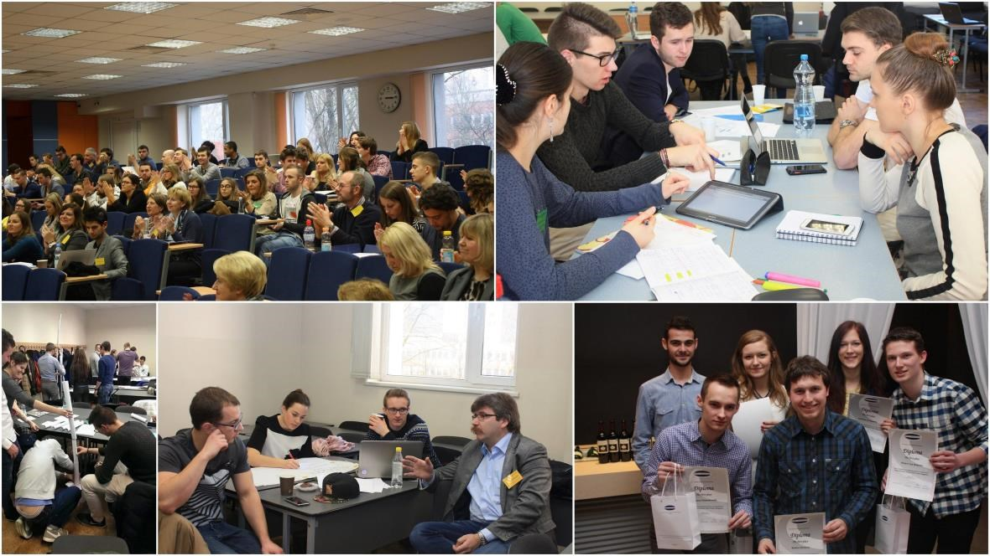

About: Project management in real live and real practice, with real needs and real people, limited resources and realistic budget under the supervision of experienced mentors
Goal: Create well founded, followed to project management guidelines, project plan for a problem, which will offer some local companies Schedule:
When | What
Monday, 25 March (2019) | - Opening ceremony, Welcome to Latvia and SBF  - School presentation  - National food presentation  - Team building activities
Tuesday, 26 March (2019) | - Lecture and discussion what is the project, the project planning  - Presentations of the projects, as well as the tasks of a Project week  - Work in Teams  - First intermediate report of the achieved results  - City Game
Wednesday, 27 March (2019) | - Introducing in the IT Software, which can help  - Work in Teams  - Mentoring round  - Work in Teams  - Second intermediate report of the achieved results  - Excursion
Thursday, 28 March (2019) | - Lecture about project finance  - Work in Teams  - Mentoring round (4) Work in Teams  - Mentoring round  - Third intermediate report of the achieved results (7) Dinner
Friday, 29 March (2019) | - Work in Teams  - Final results presentation

